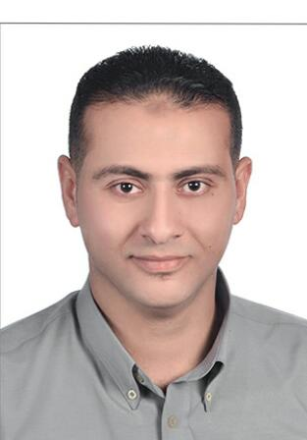
Khaled
Personal data :
Date of Birth : 17/8/1983.
Marital status : Married with two children.
Military status : exempted.
Mobile : C/o 0505891826
Graduation : 2007
E-mail : khaled.358626@2freemail.com

Objectives :
Seeking to work in a large local or multinational company Inside or outside UAE , and to be an active member in healthy motivating atmosphere dealing on a professional basis in order to increase & utilize my abilities & experience .

Education qualification :
Faculty of Arts, History department, Alexandria University, Egypt .

Languages :
- Arabic : Mother tongue
- English: good written, reading and spoken .

Previous Experience:
- Sales section manager as responsible on sector of K–Accounts & team leader as assistant to the supervisor at sanita consumer products from jan 2015 to now. (startly worked as responsible for retail van section , then responsible for new business section , then responsible for K–Accounts section)
- Sales section manager at Schweppes-Coca_Cola from apr 2013 to dec 2014 . (I was worked as responsible on retail section in Alex west) .
- Sales rep at p&g Egypt (sector of Gillette) aug 2009 to oct 2012 . (I worked as order tacker by follow-up more than 220 Pharmacy in the section of East Alexandria.)
- Admin officer at Concepts Consulting Company from jun 2006 to jun 2009. (I was working as an administrative coordinator for the internal and external affairs of the company, such as archiving and data entry and arrange visits and interviews and processing facilities and training tools and conduct many banking transactions of the company.

Computer skills :
- windows 7
- Microsoft Office
- Internet
Training courses :
- A training course on the principles of selling skills and the development of the customer .
- A training course in the quality of customer service .
- A training course in the retail's units management .

Personal aspects :
- High ability to work under pressure.
- Able to work independently and with team.
- Have high communication skills & negotiation skills.
- Have high flexibility to new concepts and responsibilities.
- Always eager to learn.

Reference :
Finished upon request

