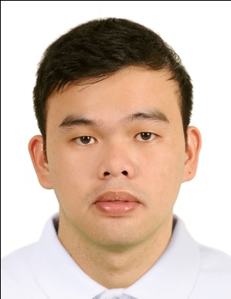
CURRICULUM VITAE

2x2 Picture

Name: Leo
Contact Numbers (Mobile): C/o 0501685421
Email Address: leo.358659@2freemail.com
Applied Position: Pharmacist

PERSONAL DETAILS

- Date of Birth: May 28, 1989
- Age: 27 years old
- Gender: Male
- Nationality: Filipino
- Marital Status: Single
- Religion: Roman Catholic
- Height: 5 feet 6 inches
- Weight: 160.2 lbs.

EDUCATION

Southwestern University, Villa Aznar ,Urgello St., 6000 Cebu City, Philippines
BACHELOR OF SCIENCE IN PHARMACY, 2ND semester of 2008-2009 to 2011

Cebu Doctors University, North Reclamation Area Mandaue City Cebu, Philippines
BACHELOR OF SCIENCE IN PHARMACY, 1st semester of 2008-2009

Cebu Doctors University, North Reclamation Area Mandaue City Cebu, Philippines
BACHELOR OF SCIENCE IN PHYSICAL THERAPY, 2006-2008

PROFESSIONAL LICENSE

- Licensing Body: Professional Regulation Commission
Professional Status: Registered Pharmacist
License/Registration No.: 0061073
Registration Date: August 6, 2012
Validity Date: May 28, 2018

WORK HISTORY

- Duration of Employment: August 6, 2012 – up to present
Name of Hospital: Leona O. Lim Memorial Hospital
Address: Canmanico, Valencia, Bohol, Philippines
Bed Capacity: 75 beds
Unit: Pharmacy Department
Position : Staff Pharmacist

- Hospital and Unit Description:
A 75-bedded private hospital that provides quality healthcare services to the patient and family. Licensed by the Department of Health and accredited PhilHealth provider.

- Job Description:
- check prescriptions to make sure there are no errors and that they're appropriate and safe for the individual patient;
- provide advice on the dosage of medicines and the most appropriate form of medication, for example, tablet, injection, ointment or inhaler;
- participate in ward rounds to take patient drug histories;
- liaise with other medical staff on problems patients may experience when taking their medicines;
- discuss treatments with patients' relatives, community pharmacists and GPs;
- make sure medicines are stored appropriately and securely;
- supervise the work of pharmacy aids;
- answer questions about medicines from within the hospital, other hospitals and the general public;
- keep up to date with, and contribute to, research and development;
- write guidelines for drug use within the hospital and implement hospital regulations;
- provide information on expenditure on drugs;
- prepare and quality-check sterile medications, for example, intravenous medications;

