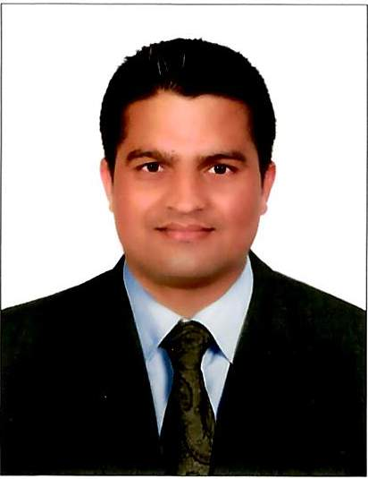

HIMLAL
Contact No – C/o 0503718643
E-mail:- himlal.358749@2freemail.com

Job objectives
Seeking for the position that best utilizes my skills and knowledge obtained from my experiences and academic study. I have strong analytical skills, fast learner, and willing to be further trained. I provide positive attitude and proven record of leadership, reliability and responsibility.

Working Experience
- Period : 17-August-2013 to till date
- Company : Gulf Greetings (Hallmark)
- Position : Export Co-Ordinator (Logistic Asst)
- Address : P.O Box No – 7924, Dubai

- Period : 17-April-2012 to 16-Agust-2013
- Company : Gulf Greetings (Hallmark)
- Position : Asst Data Entry Operator (Warehouse Asst)
- Address : P.O Box No - 7924

Job Involved in U.A.E.
- Handling all type of Data Entries and documentry for logistic.
- Incoming and outgoing goods handling.
- Documents for Out going shipment, Invoice, Packing List & Certificate of Orgins.
- Safety certificate for the all type of toys
- Co-Ordinating with Shipping company for regional shipments.
- Co-Ordinating with Regional Managers, Doha, Bahrain, Kuwait, Oman, Saudi & Egypt.
- Co-Ordinating with shipping company for Out bound and Inbound shipments.
- Preparing picking list for picker.

Key strengths
- Excellent interpersonal skills.
- Ability to work independently with minimal supervision.
- Positive work attitude.
- Keen to learn new skills to remain competitive in the face of changing technology.
- Self motivated.

Educational Qqualification
- S.L.C.(school leaving certificate) from S.L.C board of Nepal in 2007.
- I.Sc passed in 2009.(INTER MEDIATE EDUCATION)

Languages known :

English, Hindi and Nepali.

Technical Skills

- MS EXCEL, MS WORD, POWER POINT
- Email internet
- Microsoft Dynamic Nav Basic Knowledge

Skills
- Excllent communication skills both written and Oral
- Knowledge in MS-Word and Excel
- Prefessional appearance and demeanor
- Exposure to cultural working environment and advantage.

Personal Information
Name : Himlal
Date of birth : 17-Feb-1990
Marital status : Married
Nationality : Nepalese
Religion : Hindu
Known Language : English, Hindi and Nepali

If you are satisfied by the above details, please give me a chance to work in your esteemed organization and I am assure that I will do my best justify & appointment.

Yours best regards
Himlal

