PAUL

PAUL.358761@2freemail.com

Versatile, high-energy professional, successful in achieving business growth objectives within turnaround & rapid changing environment
| Finance & Accounts |Payroll/Auditing
Location Preference: Gulf countries

PROFILE SUMMARY

AREAS OF EXPERTISE
Finance & Accounts
Payroll
Auditing
Liaison & Coordination
Taxation
Team Management
- A focused professional with above 5 years of experience in Finance & Accounts,Payroll, Auditing, MIS and Reporting
- Lastly associated with I.T.L-Cosmos, (Dubai) as Accounts Executive
- Experienced in preparing monthly financials like Trial Balance, Profit & Loss a/c, Balance Sheet, Cash Flow statement, Ratios and Analytical points on Financials.
- Expertise in import/export documentation
- Expertise in complete process of Payroll up to WPS
- Strong in interaction with Auditors for Finalization of Accounts
- Experienced in preparation of monthly Bank Reconciliation statement
- Experienced in controlling Debtors & Creditors and preparation of debtors & Creditors Outstanding list and reporting to Management
- Expertise in dealing with banks for issue of Letters of Credit and Bank Guarantee and other various issues
- Expertise in Preparation of monthly schedules and allocation of expenses to branches
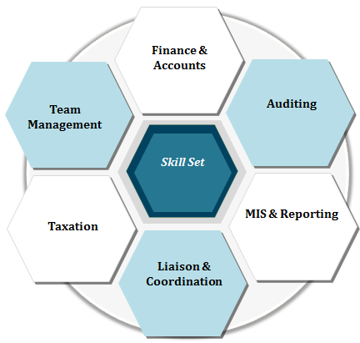

ORGANISATIONAL EXPERIENCE

Jan’15 to Feb17 International Traders M.E Limited – UAE (Dubai)
Jan’15 to Oct’14 Muthoot Finance Ltd., New Delhi as Audit Executive
Jul’11 to Dec’11 Charted Accountant Firm Mohandas & Assiciates Audit Assistant

Key Result Areas:
- Responsible for preparation & timely completion of quarterly audit programme
- Accountable for:
- Effectively doing the month closing with in 2nd of every month.
- Salary payment and month closing work completing on time.
- Drawing the outline for audit programme
- Guiding audit executives and training for new joins
- Removal of frauds
- Half yearly completion of audits at regional & corporate office specifically at finance &credit dept.
- Maintaining MIS, evaluating them for facilitating decision-making process
- Preparing tax plans, ensuring timely assessment and filing of direct & indirect tax return in compliance with Statutory Tax Acts
- Ensuring no irregularities in branches and safeguarding the assets of the company
- Conducting monthly audit meeting on regular basis

Highlights:
- Promoted as Audit In-Charge within one year from the date of joining in Muthoot Finance
- Efficiently handled major audit issues such as frauds and system procedures which are occurred in the company took effective steps such as implementation of new systems in audit in order to resolve it fast
- Holds the distinction of handling major Internal Audits such as School audit(St. George School Alakananda ,New Delhi) and departments audit of muthoot Finance Corporate office New Delhi

EDUCATION

2011 MBA (Finance) from Anna University, Tamil Nadu
2009 BBA –(Finance) from Annamalai University, Tamil Nadu
2006 Navodaya Vidyalaya, Kerala Higher Secondary Board
2003 SSLC from M.M.H.S Panthalampadam, Kerala State Board

TECHNICAL PURVIEW
- Proficiency in:
- Microsoft Applications such as Excel, Word, PowerPoint
- Accounting Basics
- Tally ERP
- Oracle
- Orion

.

