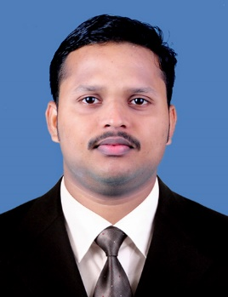
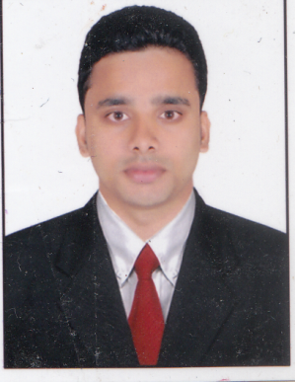
CURRICULUM VITAE

ROBERT
MBA (FINANCE&MARKETING)
ROBERT.358781@2freemail.com

Career Objective
To work in a challenging environment, demanding all my skills and efforts to explore and adapt myself in different fields, and realize my potential and contribute to the development of organization with impressive performance.

Interpersonal Skills

- More than 1 year professional experience in India.
- Able to work under pressure to meet deadlines
- Excellent team work and organizational skills
- Can work effectively in a multicultural environment
- Highly self-motivated, energetic, positive team player with the ability to lead
- Hardworking, Punctual and Energetic.

Employment History
I have ONE year experience in SR. Officer in Finance at Muthoot Microfin Ltd, Cochin, Kerala, India.

Responsibilities:

- MIS preparation
- Monthly and Quarterly compliance of banks.
- Loan statement verification
- Current Account opening and net activation.
- Interest reconciliation.
- Repayment of loans and other mandatory payments.

Academic Records
- Master of Business Administration (MBA) from Kannur University, and passed with 72% mark.

- Bachelor of Business Administration(BBA)from Kannur University, and Passed with 56% mark.

- Plus Two from Higher Secondary Education in Kerala, and Passed with 65% mark.

- SSLC from Kerala Secondary Education Examination Board, Kerala, and Passed with 75% mark.

Academic Project
- One Month Internship Organization Study at Reliance Retail, Bangalore.
- Done a Project topic of ‘a study on Inventory Management’ at Travancore Cochin Chemicals, Cochin, Kerala.

Skills & Others
Proficient in:
- Proficient in MS Office Package User i.e. Excel, Word etc.
- Proficient in Tally ERP 9
- Operating Systems: Windows 95/2000/XP/7/8

Additional Qualification
- Graduate in Virtual Interactive Business Experiment System (VIBES), Certified by Sree Sankaracharya Computer Centre. This is an Accounting software package.

- It includes Indian and Foreign accounting Software’s.

- Indian Accounting Software’s are Tally and Tread essay, Foreign Software’s includes Peachtree, Quick book.

Declaration
I do hereby declare that all the above information is true to the best of my knowledge and belief. Original documents will be produced on demand if essential.

Place: UAE
Date:

