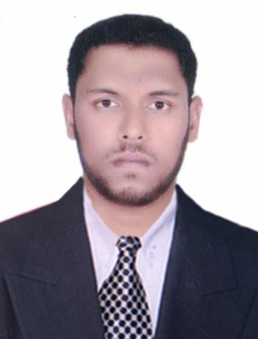
FAISAL.
Email: FAISAL.358785@2freemail.com

Career Objectives

To seek a position in an organization suited to my abilities and giving my best performance, which will benefits the company i join. To be a part of an organization wherein I can use my skills , strong educational background and my efficient interactive abilities to co-operate and work well with people.

Academic Qualification:
Course | Institute/College/School, Location |  | University/Board | Percentage | Year of Passing
 |  |  | Calicut University | 51% | 2010
B Com |  | St.mary’s College, Puthanangadi
HSC | Government Higher Secondary School Mankada |  | Kerala State Board | 73% | 2007
SSC | Aided Mapila High School Thirurkad |  | Kerala State Board | 69% | 2005

Work Experience
I have experience in Retail Industry and Real Estate since February 2011.
I have good experience in Cash handling, Bank Reconciliation and Customer Service.

Computer Knowledge
- I am familiar with Microsoft Office Packages such as Microsoft word.
- Internet Savvy
- Tally

Personal …..Qualities………………………………………………………………………………………….

- Able to handle pressure situations
- Flexible and adaptive
- Enthusiastic
- Comfortable in new situations and meeting new people

Personal Profile

Name | FAISAL
Age & Date of Birth | 27 years, 07th January 1989
Sex | Male
Community | Islam
Languages acquired | English, Hindi, Arabic and Malayalam
Nationality | Indian
Marital Status | Married
Father’s name | Abbas.A
Hobbies | Reading, Listening Music, and playing football.
Visa Status | Employment

Declaration

I do hereby declare that the information provided above is true to the best of my knowledge and belief.

