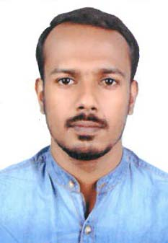
Roy

Email: roy.358896@2freemail.com

CAREER OBJECTIVE
To secure a challenging position with a progressive, reputable company with advancement opportunities utilizing my organizational skills and in the field of medical billing and coding.
ACADEMIC SUMMARY
- Medical Coding [CPC] - 2017
- Basic BSc Nursing – 2012
(Rajiv Gandhi University of Health Sciences)

AREA OF EXPERTISE
- Proficient skills in execution of professional coding in an exact way
- Possess knowledge of utmost quality related to medical coding methods and guidelines, including ICD-10, CPT and HCPCS
- Documentation and record maintenance
- Medical and Surgical Ward
- Providing medications
- Time management

PROFESSIONAL EXPERIENCE
Staff Nurse (Medical and Surgical Ward)
11/10/2012 to 16/12/2014
Oyster and Pearl Hospital- Pune
- Delivering expert nursing care, monitoring and maintaining standards of care.
- Ongoing informal and formal assessment of patients in order to provide the most beneficial care.

- Identify and act on changes in patient condition, making safe, timely decisions appropriate to the situation.
- Maintain up to date case records and care plans.
- Provide timely reports to nurse in-charge and doctors.
- Work with colleagues to provide support to all ward staff.
- Contribute to the induction of new staff acting as a mentor when appropriate.

MAJOR JOB RESPONSIBILTIES
- Total patient care based on nursing process approach.
- Unit preparation for receiving the clients and for discharging the clients.
- Monitoring vital parameters, blood gas analysis, intake output chart and documentations.
- Administration of medications.
- Administration of intra venous therapy including electrolytes and blood products.
- Able to manage life supporting equipments.
- Pre and post-operative care of clients.
- Maintain accurate records.
- All Routine investigations.

PROFESSIONAL SKILLS
- Able to perform or explain the phenomenon, possible solutions and creative methods for proceeding.
- Providing holistic quality nursing care to the patient.
- Versatile and enthusiastic hard worker.Ability to adapt and understand collaborating practice.
- Ability to communicate in a professional and impelling manner.
- Effective leadership, Compassionate, Confident, Critical thinker, Adaptable and Good learner

TECHNICAL SKILLS
- MS-Office

PERSONAL INFORMATION
- Date of Birth : 08.08.1987
- Gender : Male
- Nationality : Indian
- Marital status : Single
- Date of expiry : 27/11/2023
- Languages Known: English, Malayalam, Tamiland Hindi.

DECLARATION
I hereby declare that the information furnished above is true to the best of my knowledge.

Roy
Place:
Date:

