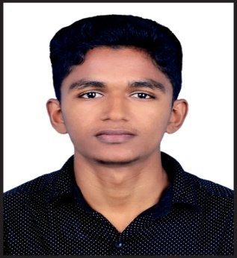 | SHUHAIB  Graphic Designer  C/o 0502360357 Shuhaib.358912@2freemail.com
PERSONAL DETAILS  Date of Birth : 7/12/1995  Sex : Male  Marital Status : Single  Religion : Muslim  Nationality : Indian  Driving License : Valid Indian Driving license  LINGISTIC PROFICIENCY  - English (Read,write,Speak)  - Hindi (Read,write,)  - Arabic (Read,write)  - Malayalam (Read,write,Speak) | Objective
 | To secure a challenging position where I could get ample opportunities to explore my talent and professional skills.
 | Work experience
Photographer&Designer
Worked with Mass media creative studio For One Year as an designer & photographer

Graphic Designer
Worked with HI-LITE flex &vinyl printing For Six month as an designer .

 | Education
Bachelor of Commerce(B.Com)
(Co-operation)
M.K University, Madurai, Tamilnadu

Higher Secondary Education
Kerala Board of Examination.

SSLC
Kerala Board of Examination.

 | Computer Skills
Graphic Designing
- Adobe Illustrator
- Adobe Photoshop
- Adobe Corel Draw
- Adobe Indisign
- Adobe Pagemaker
- ISM

Microsoft Office

- Microsoft Word
- Microsoft Excel
- Power point

Typing (Arabic,English,Hindi,Malayalam)

Better Handling Internet Applications

Software for Windows

 | Diclaration
I confirm that the information provided by me is true to the best of my knowledge and belief. Necessary documents will be produced as per the requirement.

SHUHAIB

