CURRICULUM VITAE

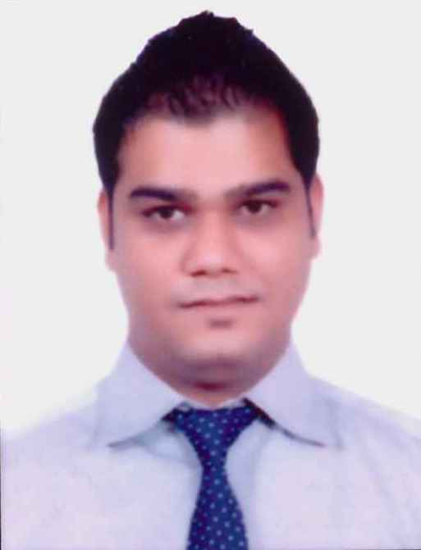

Gaurav
Mobile: C/o 0503718643
Email: gaurav.358934@2freemail.com

OBJECTIVES:
To work with a reputed organization in a position where I can develop and utilize the versatile and skill set, add demanded values to the organization.
PROFESSIONAL EXPERIENCE:
1. Bar Tender at Arsinoe Beach Hotel Cyprus (Europe) from June 2006-february 2010
2. As Cook (Continental) at ChillOut Café lounge Cyprus (Europe) from March 2010-May 2012
3. Supervisor at ChillOut Café lounge Cyprus (Europe) from June 2012-June 2013
RESPONSIBILITIES:
- Supervising food service assistants and kitchen staff, organizing their daily duties and monitoring performance.
- Ensuring that appropriate levels of hygiene and cleanliness are maintained in the kitchen.
- Making sure that all food at point of delivery is of the highest quality.
- Responsible for high standards of food, hygiene, and health and safety.
- Constantly checking the quality of the food being served to customers.
- In charge of stock control for the freezers, pantries and store rooms.
- Encouraging junior staff in their training and development.
- Contacting suppliers and ordering vegetables, meats, kitchen and cleaning equipment.
- Collect cash for beverages or drinks served and record sales
- Engaging the guests in conversation.
- Preparing cocktails and other drinks.
- Maintaining appropriate stock levels for the bar.
- Ensure that the coffeemaker is in perfect working condition at all times
- Prepare coffee in front of the customers and take any input in a positive manner
- Responsible to ensure smooth operations exists in assigned area, including: staffing, inventory, quality assurance and customer service.
- Investigates and resolves food quality, employee, and service complaints.
- Inspects dining area and ensures cleanliness, organization and dining area courtesy.

KEY SKILLS:
1. Result oriented and Hardworking
2. Can lead a team to achieve the goal
3. Hospitality & Culinary Management
4. Guest Service Excellence
5. Multioutlet Operations

EDUCATIONAL QUALIFICATION:

Class | Subject | School/University | Board/Degree/Diploma | Year
Hotel Administration |  | The CTL EUROCOLLEGE Cyprus | Diploma 2 years | 2005-2010
BA | Economics, Public Administration, Political Science | Punjab University | Degree | 2001-2004
12th | Arts | Shri Guru Gobind Singh SR Sec School | CBSE | 2000-2001
10th |  | Sanjay Public School | PSEB | 1998-1999

STRENGTHS:
Good Communication skills, hardworking and dedicated.

ACHIEVEMENTS:
1. Best employee from the BAR Department Year 2008 From Arsinoe Beach Hotel Cyprus(Europe)
2. Promoted to Supervisor from Cook by seeing the past experiences.

PERSONAL DETAILS:

Date of Birth : 18 May 1984
Sex : Male
Marital status : Unmarried
Nationality : Indian
Languages known : English, Hindi and Punjabi

(Gaurav)

