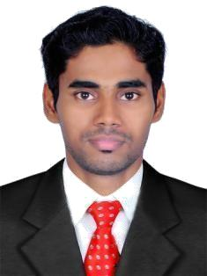

ASIF
ASIF.358944@2freemail.com

Career Objective

Want to work as an Accountant/Administration/Sales & Marketing in a well reputed company like you.

Working Experience

1. ASIAN GOLD&DIAMOND, EDAPPAL

Worked as an Accountants assistant at ASIAN GOLD& DIAMOND, Edappal, Kerala, India from JUNE 2014 To february 2017
Education

2001 | - 2014 | B.com with Computer Application
 |  | Calicut University, Calicut.
 |  | Aggregate: 70%
2009 | - 2011 | Higher Secondary Education
 |  | Modern higher secondary school pottur.
 |  | Aggregate: 66%
2008 | – 2009 | S.S.L.C
 |  | modern Higher Secondary School,
 |  | pottur Aggregate: 75%

Project Details

PROJECT

Project Title : A Study on patient satisfactionin KMM Hospital puthampalli, Kerala, India.

Duration : 6 Months

Personal Skills

I am a well disciplined, dedicated person with a strong desire to learn new things. I am good at deals with people diplomatically and impressively.

Co-Curricular Activities

Participated in District sports meet in HS and HSS level Participated in District arts competition in HS and HSS level

Computer Skills

Tally Erp.9

Microsoft Office , Quick book

Strength

Discipline and strong sense of responsibility

Self-motivation and introspection.

Meet strict deadlines and quick learner.

Personal Details

Sex : male
Date of birth : 18.03.1993
Nationality : Indian
Visa status : Visit visa (valid till 23-06-2017)

Languages Known

English | Read | Write | Speak
Malayalam | Read | Write | Speak
Hindi | Read | Write | -
Arabic | Read | Write | -

Declaration

I hereby declare that the information furnished above is true to the best of my knowledge.

