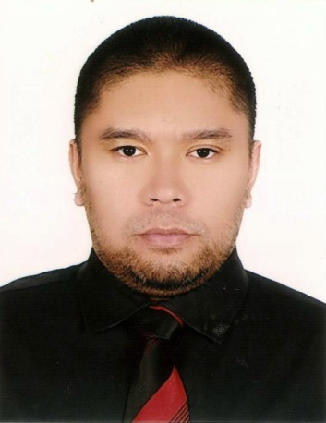

TRISTAN
TRISTAN.358972@2freemail.com

OBJECTIVE
To be able to work in a reputable company where I can apply my skills and abilities and to grow both professionally and personally.

WORK EXPERIENCE
IT Assistant & Team Leader | September 2013 – present
Feather Management Consultants | Abu Dhabi, UAE
- Procurement of required company and client hardware and software.
- Ensures documents and sensitive data are properly archived for efficient identification and retrieval.
- Meet with people outside the company, including potential clients for purchases.
- Purchasing, installation, and maintenance of office and client systems as needed.
- Assists employees, clients, and new users in proper usage of systems.
- Inventory management of IT supplies and equipment.
- Provide Remote Desktop Assistance to the office and clients as needed.
- Generate User Manual(s) / Knowledge Base Articles (KBAs) for the End-User regarding new and/or existing systems.
- Distributes tasks to appropriate team members to ensure efficiency and accuracy of the task at hand.
- Organize monthly staff schedule.
- Generates daily, weekly and monthly task and employee performance reports
- Addresses team concerns to be forwarded to other supervisors.
- Coordinates with other Team Leaders to ensure proper handover of tasks.

Administrative Assistant | March 2011 – July 2013
Isla Rosy Wavepool & Resort | Bulacan, Philippines

- Supervise the different teams running the establishment.
- Acts as Public Relations Officer to guests and other clients.
- Personally addresses all staff and guest concerns.
- Assist in HR duties such as hiring, interviews, payrolls, and employee scheduling.
- Designates required training for employees.
- Generate Action Plans for emergency and non-emergency situations in and around the establishment.
- Formulate strategies, entertainment, and activities as required by the peak and off-peak seasons.
- Perform daily inspection routine to ensure safety and efficiency of the establishment.
- In charge of all marketing (print and digital) for the establishment.
- Design and Layout of all marketing media for the establishment.
- Manager-in-training.

Technical Support Representative Tier III | March 2010 – 2011
Teletech | Laguna, Philippines

- Handled highest level escalated client concerns.
- Provide Cable and Internet Technical Support to customers via VOIP.
- Provide advanced technical support to clients via Remote Desktop Assistance.
- Meet and maintain key employee performance metrics as required by the TSR role.
- Clients include AT&T U-Verse (USA), Dell (USA), and Telstra BigPond (Australia).
- Provide support to IT Team by sorting out network cables, dispatching terminals, assigning IP addresses and access filtering of terminals around the production floor.
- Internship with IT department.

EDUCATION
2010 | Bachelor of Science in Computer Science
| University of Perpetual Help System Laguna, Biñan City, Philippines

2005 | Advanced Diploma in Business and Information Technology
| Informatics International College, Eastwood City, Philippines

2003 | Advanced Diploma in Information Technology
| AMA Computer College, Makati City, Philippines

TRAININGS and SEMINARS
2015 | Cisco Certified Network Associate (ongoing)
| Microsoft Certified Solutions Expert
| Unity 3D Game Development and Design
| CompTIA Network+
| Red Hat Certified Engineer (ongoing)
| Red Hat Certified System Administrator (ongoing)
2013 | Computer Systems Servicing I / II
| Game Design and Implementation

2011 | Advanced Graphic Design for Print and Other Media

SKILLS
- Knowledgeable in using MS Word, Excel, and PowerPoint
- Knowledgeable in using Visual Basic.net, C/C++, and Java Programming
- Knowledgeable in using Adobe Photoshop and Illustrator
- Knowledge in Advanced PC Hardware Troubleshooting
- Proficient in Windows and MAC OS Environments
- Proper Phone Etiquette
- Proficiency in English language use and grammar
- Knowledge of relevant computer software applications and hardware
- Team-player
- Ability to multi-task

PERSONAL INFORMATION
- Date of Birth September 6 1982
- Place of Birth Manila, Philippines
- Age 34 years old
- Marital Status Married

