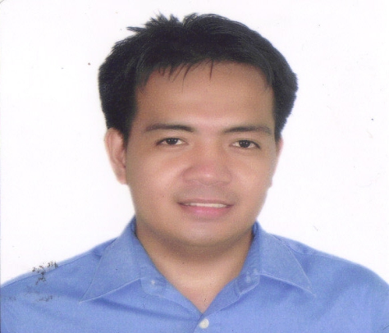

ERWIN A
Contact No. C/o 0505891826
Email. Erwin.358995@2freemail.com

OBJECTIVES:

To build a career with an organization where I may utilize and maximize my knowledge, skills and strengths.

EMPLOYMENT HISTORY:

SALES REPRESENTATIVE
Yummy Ice Cream
Mina Center-kiosk
Abu Dhabi-UAE
May 3,2016-up to present
DUTIES AND RESPONSIBILITIES
Great and deal with the costumer,
maintain the quality and cleanliness of the product, monitoring the sales, make daily inventory report of
the sales and stock

SALES PERSONNEL
Afficionado Germany Perfume
Super 8 Cogeo gate 2 Antipolo City-Philippines
October-december 2014
: DUTIES AND RESPONSIBILITIES
Deal with the costumer, Monitoring the sales, stock and the expiry date of the perfume and make a weekly inventory report of
the store.

SALES ASSISTANT
Rough Rider Jeans (RRJ)
River Banks Marikina City-Philippines
May-sept. 2014
:DUTIES AND RESPONSIBILITIES
Asist the costumers in the outlet and give them some idea about the product knowledge of the item that they looking for.

MERCHANDISER OFFICER
Pampangas’Best Inc.
Kamuning Road Quezon City-Philippines
June-Dec 2013
DUTIES AND RESPONSIBILITIES
Monitor the display, expiry date and sales of stock of the frozen products of Pampanga’s Best Inc.
In the selected stores

RDU-CLERK OFFICER
SM Main Warehouse
Brgy. Lhauerta Parañaque City-Philippines
Feb. 11- June 25 2009
DUTIES AND RESPONSIBILITIES
Receive and check the item product of SM Super Market such as item barcode,
Expiry date, case barcode and the quality and quantity of the product

LABELLING OFFICER
Pure Foods Hormel
Parang Marikina City-Philippines
June 12- Nov. 2008
DUTIES AND RESPONSIBILITIES
Label and check the quality of the in-can product of Pure Foods San Miguel
Corp.

PERSONAL INFORMATION:

Date of Birth January 30, 1985
Place of Birth San Vicente Camarines Norte
Nationality Filipino
Civil Status Married
Height 5’6
Weight 128 lbs.
Religion Roman Catholic

PERSONAL ATTRIBUTES:

: Capable to operate computer, can speak English/ Basic Arabic
: Hard working, dedicated to work aggressive and punctual
: Able to work under pressure and minimal supervision
: can handle multi-tasking situation

EDUCATIONAL ATTAINMENT:

Tertiary : Graduate-Bachelor of Arts Major in Sociology
Camarines Norte State College
Daet Camarines Norte Philippines
March 2006

Secondary : San Vicente Parochial School
San Vicente Camarines Norte Philippines
March 2002

Elementary : San Vicente Elementary School
San Vicente Camarines Norte Philippines
March 1999

I hereby certify that the above information are true and correct to the best of my
Knowledge and belief.

ERWIN
Affiant

