SALIH 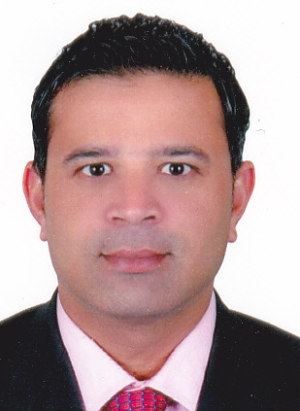
Salih.359009@2freemail.com
C/o 0504753686

To establish a professional with your esteemed organization by a challenging position, that suits my Admin skills,abilities,knowledge,towards career advancement and excellence by gaining valuable experience from the job and blending my growth opportunities with that of the organization.

Core Competencies:
- Possess excellent administrative and interpersonal skills
- Ability to perform tasks under pressure
- Knowledge of customer relationship management and contact management contact systems
- Highly skilled in managing time organizing work priorities
- All kind of L/C work dealing with different banks like Emirates NBD,HBZ,BSI,BMI
- Operate desktop computer to compose and edit correspondence and memoranda from dictation ,verbal direction, and from knowledge of policies of established departments and divisions,prepare,transcribe,compose,type,edit and distribute agendas and numerous minutes of meetings
- In depth knowledge of various computer applications with good typing speed
KEY SKILLS

Communication : Good communication skills and a good listener too.
Managerial : Would like to organize, face challenges and lead the team to success.
Strengths : Positive attitude with focused mind and determination.

PROFESSIONAL QUALIFICATION

- Bachelor in Commerce
- Ticketing Course
- Diploma in Computer Hardware

COMPUTER SKILLS

- Operating System Various Windows Operating System
- Applications MS Office
- Presentation Tools MS PowerPoint
- Internet Web Browsing ,Searching, Surfing Net with good typing speed
WORK EXPERIENCE

. 2015 to Date GO GREEN GROUP OF COMPANIES, J.L.T
Working as a P.R.O, Four Dubai Local companies and Jebel ali Free Zone,
DMCC,
(Acme pick L.L.C, Al Mutawassit L.L.C, sea harvest L.L.C, acme dig itch JLT,
GO Green co FZCO,)
. 2013 to 2015 ICT GENERAL TRADING L.L.C
Purchase and Traveler, Food Items,

- 2006- to-2013 BFT Trading FZCO
- Administrator dealing with LC – (Letter of Credit) as well
: Marketing and Purchasing Traveling, Thailand, Iran, Malaysia, Vietnam.
Kenya South Africa,
- 1996-2006 Heliopolis Computer Co. L.L.C
PRO responsibilities, Courier and Documents services

- 1994-1996 Karama Automobiles
Sales Representative for Automobile Parts& Accessories

- Before 1996 Government Driving School
Kuttichara, Kerala, India
Driving Instructor

Work Experience covering all activities related to Customs Clearance at Jebel Ali,
Port Rashid, Airport Cargo in Dubai
Doing clearing job and P.R.O works at Chamber of Commerce, Dubai Municipality
Dubai Police, Traffic Dep and Dubai Economic Dept.

PERSONAL INFORMATION

- Date of Birth 20 May 1972
- Gender Male
- Nationality Indian
- Marital Status Married
- Visa Status Employment
- Languages known English,Hindi,Malayalam,Arabic
- Driving License Valid U.A.E driving license

REFERENCE

Will be provided on request.

