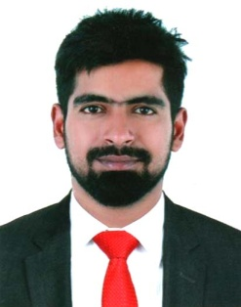

Mohammed
Mohammed.359266@2freemail.com

Career Objective:
To obtain a position in sales& customer service where I can utilize my experience & make use of my knowledge & skills by being a part of dynamic team & work towards self and organizational growth.

WORK EXPERIENCE
Company: Planet Fashion, an Aditya Birla Group Company
Designation: Sales Advisor
Duration: May2014 till Jan2017
Key Result Areas:
- Indoor sales and attending walk in customers
- Advise customers regarding the ongoing promotions & bundle offers and increase the sales revenues
- Handling complex customers queries and complaints
- Ensuring visual marketing and styled window displays are in line with seasonal themes
- Analyzing the buyers trend and advising the store manager regarding the demanded inventory
- Ensuring the minimum inventory level is maintained at all times by replenishing the stock in time
- Maintaining the customers database
- Invoicing and cash control

Company: Omega Health Care Services
Designation: Process Executive
Duration: Jan2013 till Feb2014
Key Result Areas:
- Advise customers of available personal insurance products that suits their lifestyle
- Look for new clientele by means of telemarketing with the goal of generating new prospective clients
- Staying abreast of the ever-changing environment by attending meetings, seminars and programs to further learn on new products and services
- Be a trusted advisor helping clients manage the risks of their everyday life by educating them about potential gaps in their insurance coverage
- Provide prompt, accurate, and friendly customer service which includes responding to inquiries regarding insurance availability, eligibility, coverages, policy changes, claims submissions, and billing clarification
- Assists with maintenance of client policies and data entry of book of business in the paper unit
- Cross trained for customer service, customer retention department
- Perform adjustments; maintain detailed records of policy transactions, complaints and data entry functions
- Process client accounts in accordance with the departmental and institutional policies and procedures.
- Communicate with client via telephone& e-mails
Education:
- Grade 12, National Institute of open schooling, Mangalore, India
- Grade 10, Crescent International School, Chennai, India

Technical Skills:
- Microsoft Office
- Microsoft Outlook
- Adobe Photoshop

I certify the above information is true to the best of my knowledge & references can be provided upon request.

