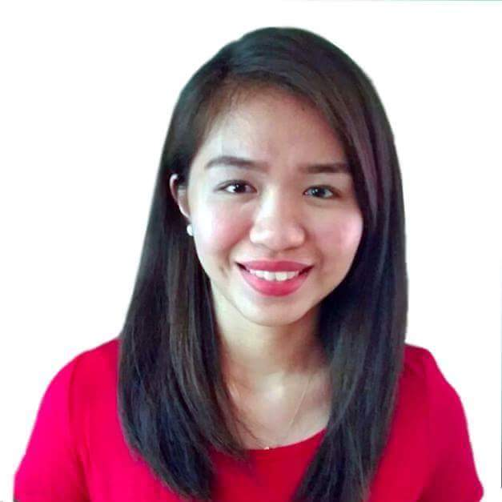
JOLENE
JOLENE.359283@2freemail.com
2-Year Experience in the Banking Industry
In a prominent financial institution in the

EXPERIENCE
BANK TELLER
April 2015 – March 2017
United Coconut Planters Bank (UCPB-established in 1963 )
Background :
- Average 200-300 transactions per day
- Issuance of manager’s cheque
- Foreign exchange
- Dollar to peso to dollar transactions
- Outward remittances
- Bills purchase
- Debiting of customs transactions
- Tax Payments
- Computer efficient
- Excellent customer service practice
- Multi tasking – tellering, balancing of cash, reviewing of transactions within the day and filing

ON-THE-JOB TRAINEE as Audit Assistant
November 2014 – February 2015
Department of Interior and Local Government
Under the requirement of the college course curriculum
EDUCATION
College Ateneo de Davao University
Bachelor of Science in Accounting Technology
2011 – 2015
Secondary University of the Immaculate Conception
2007 – 2011
Primary Davao City Special Education
2000 – 2007

PERSONAL INFORMATION
Birthdate : July 9, 1994
Birthplace : Davao City, Philippines
Nationality : Filipino
Height : 5’4’’
Weight : 53 kgs.
Age : 22 yrs. old

