EHSAAN
EHSAAN.359284@2freemail.com

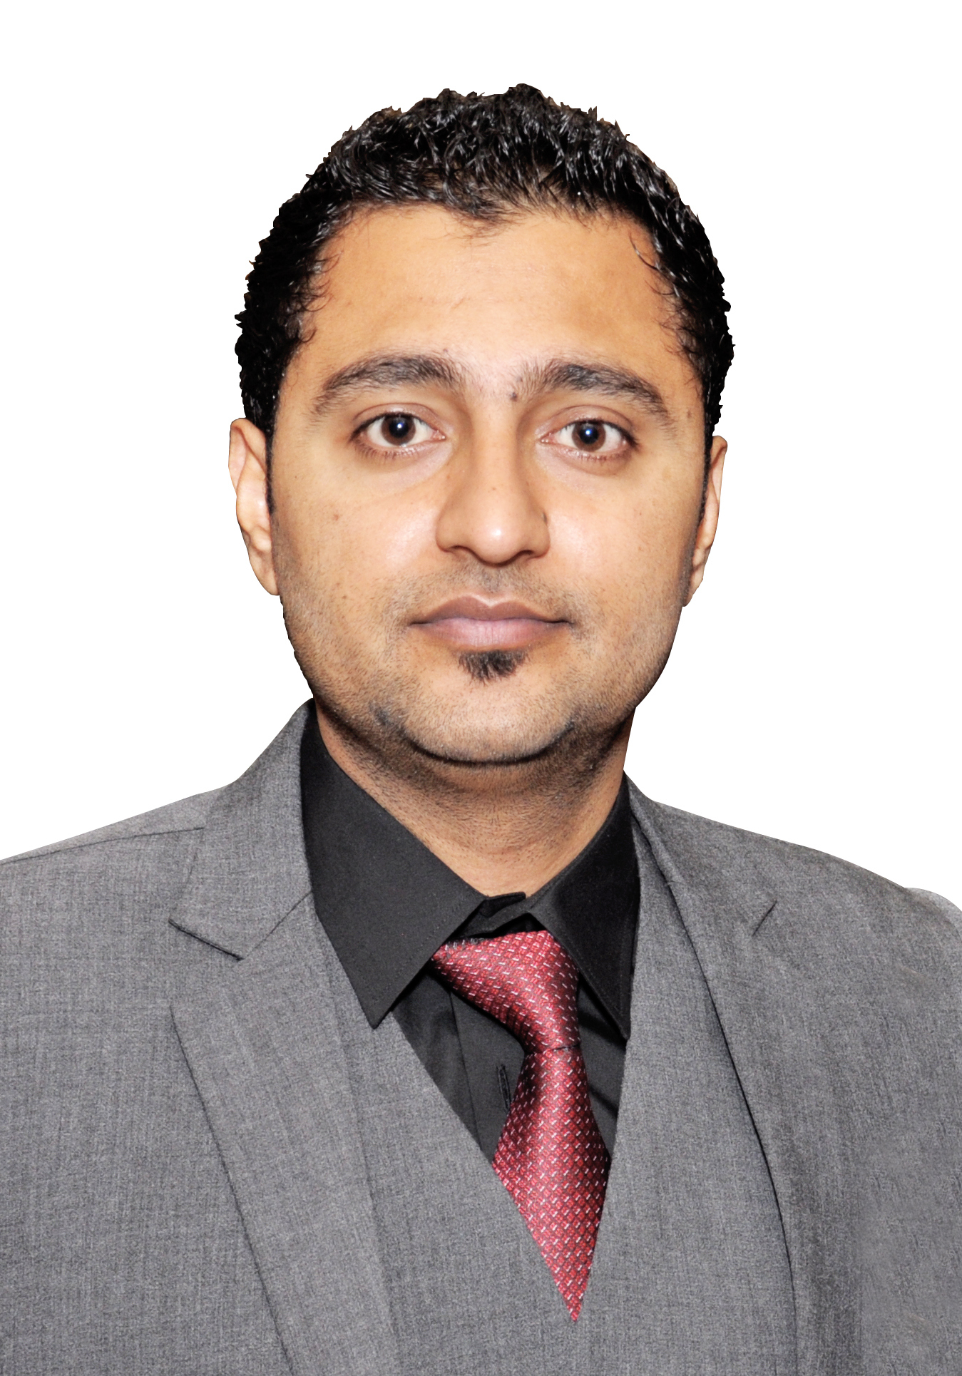
Visa Status: Visit visa
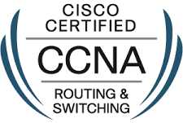

Professional Summary
- IT Professional with experience in System Administration, Network Administration,
- Experience in Server administration, System Integration and problem resolution.
- Experience of Gigabit Passive optical networks, GPON Specialist, GPON System Integration.
- Experience in Deployment of FFTH triple play Services (Video, Voice and Data).
- Experience in Network Troubleshooting, Traffic Flow analysis in real-time.

Professional Experience
Next Level Communications Pvt. Ltd | Senior Network Engineer Broadband
October 2015 to March 2017
- Installation, commissioning and configuration of Calix E-Series Access Network and Power System of Delta Energy Systems (Switzerland),
- Service provisioning of Video, Voice, Data, IP-TV and VOD services in a VLAN per Service model.
- Troubleshooting rouge ONTs and Factors effecting Access network performance.
- Troubleshooting SIP based VoIP connections.
- Providing support to Internet Services Providers (ISP) that utilize the Calix E-Series access platform, Calix Management System (CMS) and Calix Optical Network Terminal (ONT) Devices.
- Deployment of Link Aggregation (LAG) and Ethernet Ring Protection Switching (ERPS).
- Test Plans and Test Procedures for the various features of E-Series platform.
- Configuration of SIP, HIS & MVR on Calix Management System (CMS).
- Evaluation of existing network infrastructure to identify opportunities for improvement.
- Planning, Configuring and Deploying FTTx GPON Optical Fiber Network of Alcatel, Huawei & Calix Inc.

Host Break web Technologies Pvt. Ltd | System Engineer
September 2014 to October 2015
- Installing and conﬁguring computer hardware, operating systems and applications such as MSSQL server, Smartermail SMTP server, IIS 7.5 server installation over windows server 2008 R2. DNS server and management of DNS zone ﬁle keeping primary and secondary zones synced.
- Installation of virtual machines (windows server 2008, R2, Centos, Debian, Ubuntu over HYPE- V. Detailed Knowledge of GPS technology and its use to do the survey, take points and trails along the way to use them afterwards for better understanding and planning of the route.
- Monitoring and maintaining computer systems and networks and all the service running over servers such as SMTP, POP service, HTTP service, MSSQL server service, Disk space, and Bandwidth utilization.
- Managing backups, Creation of database backups and restoration. Taking Virtual machine’s backups, Restoration of websites.
- Providing technical support to web hosting client and dedicated/VPS server clients. Resolving e-mail and hosting issues.
- Providing support, including procedural documentation, writing Knowledgebase articles to guide clients step by step to solve their issue on their own. Monitor server performance & do server checklist on daily basis.

SPECIAL PROJECTS
Working as Sr. Network Engineer in Next Level Communications Pvt Ltd, Successful Completed Projects are:

- Installation of Calix Access Network E7-20 in NAYAtel Pvt. Ltd
- New Macro sites planning and surveys.
- New sites redesigns and pre-optimization.
- 1x8, 1x16 and 1x32 Splitter deployment Upgradations and Passive Optical Networks Optimization.
- Successful deployment of FTTH Network in Bahria Town (Safari Villas 1 and Safari Villas 2)
- Network Upgradation of Gulraiz and Kahuta Industrial Area.
- Design, Planning and Deployment of Optical Network of Hyundai and Attock Refinery
- NADRA Project for Installing CCTV Cameras.

Certifications
- CCNA Routing and Switching
- CCNP (In Progress)
- GPON Specialist
- Ethernet Access Network Specialist
- Calix Certified Professional
- EAN Design and Engineering
Trainings Attended
Microsoft | - MCSA-Windows Server 2012 R2 Configuration  - Windows Server 2008/2012 R2 Administration  - Introduction to the Microsoft Private Cloud  - Database Fundamentals  - C# Fundamentals  - Windows Server Administration  - Networking Fundamentals
Linux | - Linux Essentials  - Linux Administration

Education
2010-2014 | Bachelor in Telecommunication and Networking  COMSAT University  Final Year Thesis & Project: Android based accidental alert and tracking system for rescue services.
2006-2008 | F.Sc (Pre-Engineering)  Punjab College Of Information Technology
2006 | Matriculation  New Siddique Public School For Boys
References to be provided on request.

