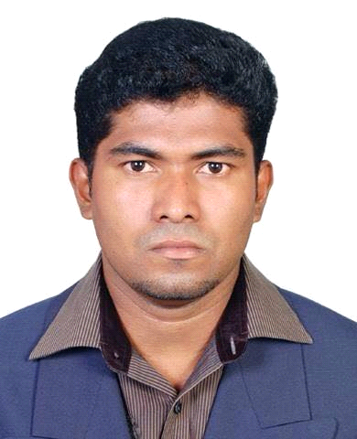
ANTONY.359294@2freemail.com

APPLICATION FOR LAND SURVEYOR
ANTONY
OBJECTIVE
To utilize creativity knowledge and excellent interpersonalcommunication skills in obtaining acarrier with a goal oriented organization.
Academic qualification:
Diploma in land surveyor (NCVT). From:-ministry of labour and employment. Attested from kingdom of saudi arabia (KSA)
12 september 2012
COMPUTER COURSES AND SKILLS
:-Diploma in microsoft office (include miccrosoft word and microsoft excel)
:-Excellent command in Auto Cad

Technical Skills
Diploma in LANDSURVEYOR from National Council for Vacation Training( Govt. of India ).Attested from KSA embassy (2012)
Profotional Experiance
Over the 6 year practical experiance with following organization in abord and indian
Working with BINSAMMAR contracting Est. SAUDI ARABIA
working as field land surveyor since 2012 to till date.
Working current projects
project of ksa ministry of water and electricity
:-sweage line (clay, fiber and concreate pipe with all kids of diameter)
:-water line
:-prepairing data out of an auto cad drawing forsite layout
:-horizontal and vertical traversing to fix control points and bench marks
co ordinating with main contractor , manhole installation ,installation supervisors and engineers according to site condetions etc.
consultants in hail region - MASSAR CONSULTANCY
- NATIONAL CONSULTANCY
Worked with standerd fabrication and engineers , desins and engineers
Checking and controlling horizontal and vertical profile of structure ,fixing and finding stake out points by co ordinates uesd total station and giving levels of ground
Job experiance
Used of total station and levelling instrumentsfor setting out of building ,roads and parking, pipeline etc..
Instruments used:
total station leica 405, and sokia cx 105,dumpy level

Declaration
I hereby declare that the above furnished information true to the best of my Knowledge.

