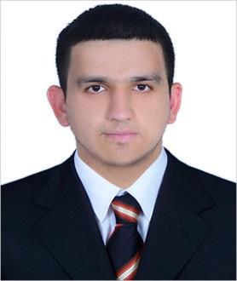
PERSONAL KOMRON
KOMRON.359316@2freemail.com

INFORMATION

International City, Dubai (United Arab Emirates)

Gender: male

Date of birth: 25 Jan 1994

Nationality: Tajik

PREFERED JOB Sales associate

WORK EXPERIENCE

02|02|2016-17|02|2017 Sales and marketing department Koton Textile, Bursa (Turkey)

-Research on new foreign and domestic markets -Follow up the customers

-Shipment process -Exporting

03|08|2014-06|01|2016 Receptionist

SHERATON HOTEL, Dushanbe (Tajikistan)

-Answering the calls

-Assistance on reservations -Team leader

01|06|2013-01|07|2014 Special education teaching associate professional

ADVANCE LANGUAGE SCHOOL, Dushanbe (Tajikistan)

-Teaching Practical and Grammatical English

ADUCATION AND TRAINING

01|09|2011-01|07|2016 Management

Tajik National University of N.Khusrav, Tajikistan

-Economics, Marketing, Accountant, Statistics

01|09|2006-01|07|2011 Foreign Language Diploma

Mevlana High School, Qurghonteppa (Tajikistan)

-English, Turkish and Russian Languages

-Maths, Physics, Chemistry,Biology

Communication skills

-good communication skills gained through my experience as receptionist;

-concise communication skills gained through my experience as sales representative; -product knowledge and demo skills gained through my experience as sales representative.

Languages English - fluent

Russian – fluent

Turkish – fluent

Farsi – fluent

