Safi Ur
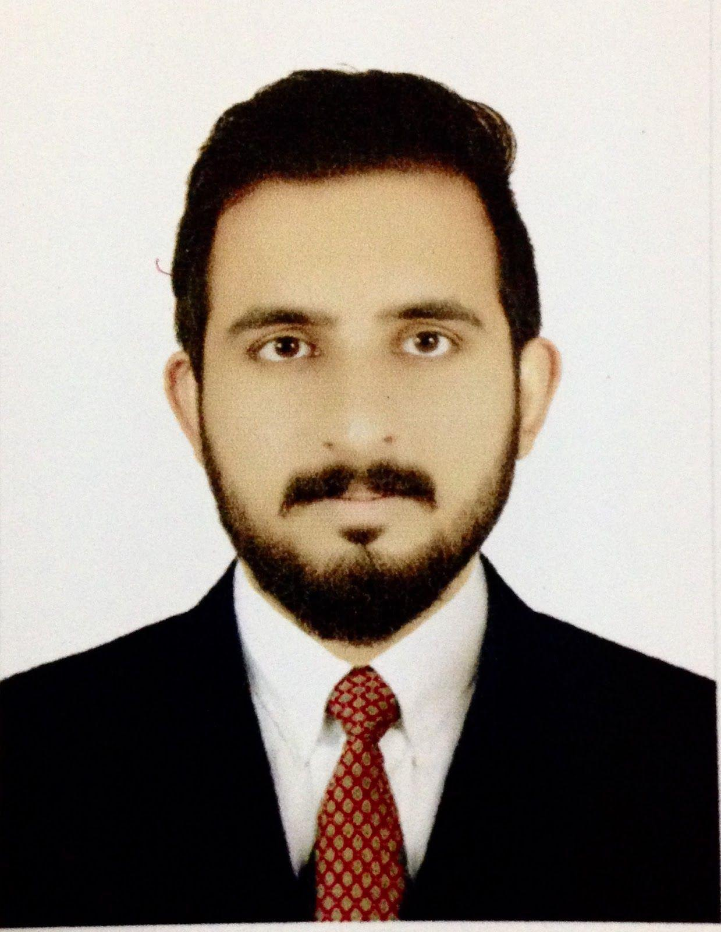
Rahman

Pakistani

OBJECTIVE

I would like to be a part of an organization that support/provide a competitive environment where I can utilize my development oriented skills.

EXPERIENCE

Group Project
Project: ​Online Car Solutions
Role: ​.net developer

- Online car solutions provide buying and selling of new/old cars and their parts

- Provides rent a car facility

- Provides maintenance or recovery using google maps

Responsibilities:

- Developed application logic using C#

- Written stored procedures using SQL in SQL server 2008

- Developed web forms using C# and ASP.NET

- Worked on cascading style sheet

- Extensively used GridViews sorting and paging

Environment: ​Visual studio, sql server 2008, ASP.NET 3.5, ADO.NET, HTML5, IIS

Solo Project

Project: ​West Hills Driving School Role: ​.net developer

A dynamic website for a Canadian based driving school containing information about the institute, timings and offers with a user friendly admin panel to update the contents of the website

Responsibilities:

- Developed the front end using HTML5 and CSS3

- Back-end coding using C#

- Developed database using SQL

- Hosting

Environment: ​Visual studio, sql server 2008, ASP.NET 3.5, ADO.NET, HTML5, IIS

Group Project Project: ​QuranSmart Role: ​.Php developer

QuranSmart is an organizations which teaches Quran to the students from all over the world over the internet.

Responsibilities:

Assistant in Developing an automated solution that helps in managing online classes, payments, registration, invoicing and online payments etc. The developed application is in used of two different institutes in Pakistan.

Environment: ​PHP, MYSQL, zend framework

EDUCATION

Pakistan education academy dubai, U.A.E

Matriculation — 2007

Computer Science

Comp-tech degree college, PAKISTAN

intermediate — 2009

faculty of science, pre engineering

Kohat university of science and technology, PAKISTAN

Master’s Degree, Computer Science — 2015

BS(CS) with specializations in Software engineering

Cisco Certified Network Associate

2016

TECHNICAL SKILLS

Software engineering skills

Microsoft Technologies​: ​ASP.NET3.5, ASP.NET4.0, ASP.NET4.5, ADO.NET,
Windows Forms
Scripting Languages​: ​PHP 5.4, PHP 5.5, JAVASCRIPT
RDBMS​: ​SQL SERVER 2008, SQL SERVER 2012, MYSQL
DEVELOPMENT TOOLS​: ​VISUAL STUDIO, DREAMWEAVER, NETBEANS
DESIGN TOOLS​: ​CSS,

Additional

Microsoft Office

Microsoft VISIO

Networking skills

- Installation and setup of routers and switches

- Knowledge of LAN technologies, Switches, Cables, Bridges

- Routing Protocol Configurations

- CDP Configuration

- Full Command in Inter-VLAN Routing

- Switching, Standard Access-list, Extended Access-list and Vlans Configurations.

- Experience of IP addressing, administrating subnets and various routing models

Languages

- English

- Urdu

REFERENCES

Available upon request.

