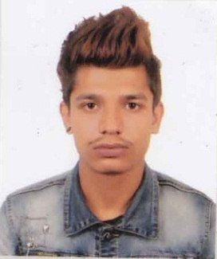

ARFAN
ARFAN.359339@2freemail.com

OBJECTIVE

Seeking a good career and holding a responsible position in the reputed organization and ensure credible performance to work towards exceeding the set goals contributes for the organization.

PROFILES

- I am a driven motivated team player with hard working, can do attitude and a passion for delivering excellent customer service.
- Pro-actively manage customer satisfaction in order to achieve 100% satisfaction.
- Enthusiastic, energetic always work with positive frame of mind to maximize my potential.
- Good Interpersonal and communication skills, excellent writing and customer service skills.
- Excellent problem solving and organization skills.
- Ability to work with tight deadlines.
- Career oriented, sincere and loyal to my work.

EDUCATIONAL ATTAINMENT
- Intermediate (10+2) from Trinity International school, Nepal

COMPUTER SKILLS
- Basic knowledge of Computer Application
- Basic Knowledge of Internet
- Basic knowledge of ms excel

WORK EXPERIENCE
- Worked as a salesman and cashier at world trade Center,Kathmandu,Nepal for 2 years

JOBS & KEY RESPONSIBILITIES

• Welcome customers with a smile as they enter into premises
• Proactively ask customer how they can be assisted
• Provide customers with product information that they need
• Escort customers to the correct aisles
• Explain product features and warranty agreements
• Demonstrate the working of a product when required
• Provide information on daily deals and promotions
• Ensure that all products are well stocked and are easy to reach7
• Assist customers by taking down products that may not be easy to reach
• Provide information regarding each product and any discount offers associated with it
• Make sure that work area and aisles are clean and shelves are dusted properly
• Respond to customers’ requests and concerns in a resourceful manner
• Handle cashier duties by taking cash or credit cards in exchange of goods sold
• Manage product returns and exchanges
• Ensure that all purchased items are delivered to the customers in a prompt manner
• Reserve products for online orders
• Discourage shoplifting activities by constantly keeping a vigilant eye
• Arrange products on shelves in a tidy manner
• Pick and pack orders for shipping purposes
• Order out of stock items in a timely manner

PERSONAL DETAILS

Date of Birth : 31/05/1998
Nationality : Nepal
Gender : Male
Marital Status : Single
Languages Known : English. Hindi & Nepali

PAS

DECLARATION

I hereby declare that the particulars furnished above are true to the best of my Knowledge and belief

