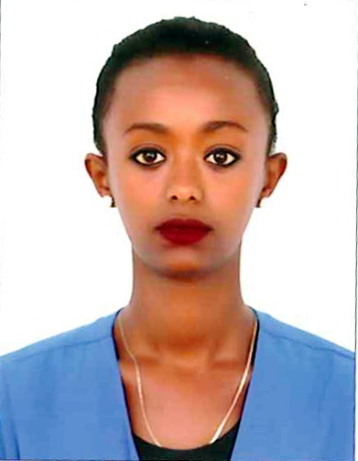
Mekedlawit
Mekedlawit.359344@2freemail.com Citizenship: Ethiopian
Gender: Female
Date of Birth: 28 Feburary 1995
Marital Status: Single
Visa Status: Tourist visa

Objective |  | Seeking a challenging and rewarding position as a SALES ASSISTANCE with your Company by utilizing my ability to maintain the company’s standards and deliver exceptional services as directed by the supervisor.
Experience |  | Sales AgentOctober 2012- March 2014  Halcomal Real Estate, Addis Ababa, Ethiopia  Duties and Responsibilities:  - Advising clients on prices, mortgages, market condition and related information  - Manage property list for sale and leasing  - Tour with clients and potential clients for property sight seeing  - Constructing a wide range of property network for referrals  Guest Relation ExecutiveApril 2014- August 2015  Ellele International Hotel ,Addis Ababa, Ethiopia ( 5 star)  Duties and Responsibilities:  - Welcome guests during check-in and giving a greet farewell to guest while checkout.  - Handling guest complaints and concerns in an efficient and timely manner.  - Overseeing VIP guests, arrivals and departures.  - Coordinating and multi-tasking job duties in a busy environment  - Should possess detailed information about the Hotel, city as well as the competition.  - Detailed information regarding arrivals and room requirements.  - Have up to date information on daily room occupancy
Skills |  | Sales and Customer Service  - Excellent ability to sell merchandize and services  - Both Indoor and outdoor sales techniques with proven results  - Excellent communication skill and Telephone manner  Management  - Staff training and supervision as well as target Achievement skills  - Strong Material and Office management skills  - Business development and management skills
Education |  | - Bachelor of Science Degree in Physics, Addis Ababa, Ethiopia  - Certificate on Introduction to computing, St. Mary’s Computer Systems  - Senior Secondary School Certificate
Language skills |  | - English: Excellent with a Western accent  - Amharic: Native
KEY COMPETENCIES |  | - Enthusiastic, self-motivated and understanding  - Excellent customer service skills and articulate and well groomed personality  - Creative, patient and persuasive with a strong desire to help people  - Leadership and entrepreneurial skills  - Exceptional ability to handle stress and work under a hectic environment  - Excellent proven multitasking skills  Declaration: I hereby declare that the information furnished above is true and correct to the best of my knowledge

