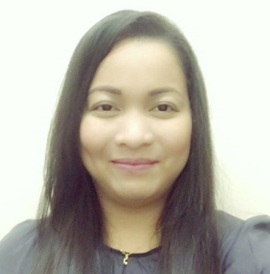

MARY

MARY.359346@2freemail.com

SUMMARY

  - Good communications and effective interpersonal skills.
  - Hardworking and willing to be trained.
  - Experience of working in a team environment.
  - I possess advanced computer skills and high proficiency in MS-Office application Word, Excel and PowerPoint.
  - Knowledgeable with electronic equipment like fax machine, scanner, money counters, etc.
  - Creative, resourceful and flexible able to adapt to changing priorities and maintain a positive attitude and strong work ethic.
WORK EXPERIENCE

PALAWAN PAWNSHOP,INC.
May 16, 2014 – September 14, 2016

Cash Teller
- Receive and pays out money.
- Keeping records of money and negotiable instruments involved in various financial transactions.
- Accountable for all receipts and disbursements.
- Count cash drawer upon opening to verify amount and ensures enough cash is kept in drawer for daily needs by ordering from vault.
- Maintains and accounts for cash drawer and daily transactions and reports discrepancies.
- Answers questions and provides information to customer’s about fees, procedures, policies or related issues

PEPP Operator (Money Remittance and Exchange)
- Process Send-out and Pay-out transactions locally as well as internationally through affiliations with international remittance partners and banks.
- Provide foreign exchange services to clients and process cash transactions in the national currencies.
- Perform Sales and Marketing Promotions to maximize sales.

New Loan Appraiser
- Acts as a representative of the company to customer’s in all transactions of the branch.
- Appraises Jewelry and other valuable items for pawns.
- Acts as the Vault Custodian of the branch assigned to.
- Handles customer complaints and urgent problems of the branch and give recommendations to immediate Area Supervisor for resolutions.
- Manages directly the branch and branch associates under my responsibility and oversees the internal and external aspects and functions of the branch operations.

RD PAWNSHOP, INC

September 01, 2010 – January 31, 2014

Cash Teller
- Receives & disburses cash to designated payee or its authorized representative.
- Prepares Cash Teller’s Remittances and Requisition Slip.

Accounting Clerk
- Prepares Daily Cash Receipts and Disbursement Report (CRDR).
- Prepare check and check vouchers of approved request check issuances.
- Check reports of daily and monthly transaction such as loans extended and loans paid blotter; loans extended and loans paid summary; goldsmith report; cashier’s report and sales report.
- Prepares daily schedule of outstanding loans.
- Prepares auction notice.
- Takes charge of office forms and supplies control.
- Acts as custodian of Master List.
- Receives office messages and communications.

Vault Custodian
- Responsible for safekeeping of pledge items.
- Custodian of Cash on Hand and petty cash.
- Prepares list of expired pledge articles.
- Receives and releases cash from/to cash teller for daily transactions.

Student Assistant

Holy Cross of Davao College
May 01. 2006 – June 30. 2010

Worked 40+ hours per week for four years during college to defray cost of tuition. I had customer service trainings when I was working as student assistant. The experience enhanced my professionalism in dealing with clients of various personalities and had the opportunity learn Microsoft Office (Word, Excel and PowerPoint) and perform several clerical and filing tasks and to apply my accounting knowledge.

EDUCATION

Bachelor of Science in Commerce
Major in Management Accounting
Holy Cross of Davao College, Inc
Sta. Ana Avenue, Davao City, Philippines June, 2010

