CURRICULUM VITAE
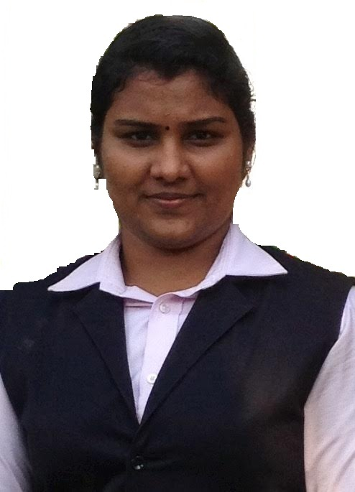
jisha.359351@2freemail.com

JISHA
Career Objective
To be a part of the organization where I can utilize my knowledge, skills and positive attitude to learn and grow along with the organization.

Post Applied For: IT Professional

Educational Qualification
Passed on
2016 | SNIT Kollam | MCA (UAE Attested) | 74%
2012 | FMNC Kollam | BSc(ComputerScience) | 62%
2009 | Govt.HSS West Kollam | Plus two | 67%
2007 | VHHSS For Girls Kollam | SSLC | 74%

Experience
Worked as an IT Document controller in Akshaya center from 12/09/2016 to 31/01/2017

Technical Skills
Language : C,C++,JAVA,PHP
OS : Linux , Windows XP/7/8
Concept : OOP, Data Structure, DBMS, SE, OS
Packages : Microsoft Office

Extra-Curricular Activities
- Active Coordinator of IT fest 2015, SNIT,KOLLAM.
- First Prize for Word hunt , SNIT,KOLLAM

Achievements
- Got First class in Kerala University for Post Graduation.
- Got First class in Kerala University for Graduation.

Personal Skills
Leadership
Adaptive
Punctual and Well Organized
Personal Details
Name : Jisha R
Address : Jijo Bhavan,Kairali nagar,Mulamkadakam,Kollam 691012,Kerala,India
Date of Birth : 12/03/1992
Languages known : English, Malayalam,Hindi,Tamil
Passport Details
Place of issue : Trivandrum
Date of expiry : 18/03/2024
Visa Details
Type of visa : Husband visa(Residence)
Issue date : 28/02/2017
Expiry date : 28/02/2020
Place of issue : Dubai

Declaration
I hereby declare that the above written particulars are true to the best of my knowledge and belief.
Date :17/02/2017 yours sincerely
Place : Dubai JISHA

