. 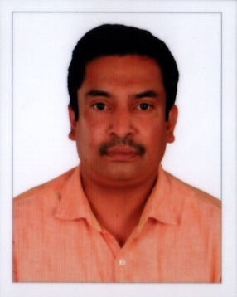

DEEPU DEEPU.359376@2freemail.com

Role<Finance consultant>

Experience Summary

I am a Post Graduate in Master of Financial Management and have worked in Finance domain for a total of 15 years. I have experience in automobile domain etc...

Current Job profile

The details of the various responsibilities that I have handled are listed here.

Company | AL Hajer Trading & Cont.Co
Period | August 2005 to present
Software used | Tally, Oracle, MS Office
Tools | Windows XP
Role | Manager
Responsibilities | - Stock In-Charge and computerised inventory management & regularly conduct stock taking of Automobile spare Parts, Auto Paints, Auto Tyres, Auto accessories, Auto windscreen Glasses.  - Accountant: - Prepared computerised financial statements frequently and audit of accounts.  - Insurance In-Charge: - Handle Motor accident Claims and undertake repair of Vehicles.  - Manager: - Company management and over all administration of office work.

Company | Sales Tax Practitioner Office Kottayam.
Period | October 2002 to July 2005
Software used | Tally , MS Office
Tools | Windows XP
Role | Tax Accountant
Responsibilities | - Prepared computerised and manual financial statements like Trading, Profit & Loss Account and Balance sheet of various concerns.  - Prepared Computerised and Manual Cash Book and Ledger of various firms.  - Undertake audit of accounts of different organisations.

Summary of Experience

- From 1st February 2001 to 31st August 2001 as Trainee in Manganam Service
Co- Operative Bank Kottayam, Kerala.

- From 5th September 2001 to 30th September 2002 as Accountant in Kalarickal
Cardamom Estate, Anakkara Kumali, Kerala.

- From 1st October 2002 to 31st July 2005 as Accountant in a Sales Tax Practitioner
Office Kottayam.

- From 19th August 2005 to 20th September 2016 as Accountant, Manager and Insurance in Charge at
Al Hajer Trading&Cont.Co {Car service Centre} Al Khabourah, Sultanate of Oman.

Qualifications

Degree and Date | Institute | Major and Specialization
Higher Diploma in Co-Operation & Banking December 31st 2000 | N.S.S Co-operative Training College Kottayam | HDC, Co-Operative Management, Banking, Audit & Accounts
Post Graduation June 31st 2004 | Pondicherry University | MFM Financial Management
Graduation March 31st 1999 | K.G. College Pampady | B.A. Economics & Banking
Pre-Degree March 31st 1996 | K.G. College Pampady | Economics

Skills
Enjoy team work brings best out of me, but individual challenges are My real taste.
Have good Communication skill in English, Arabic, Hindi & Malayalam.

Interests
Music & Establishing supporting relationship with members.
Personal Details

Age, Date of Birth : 39yrs, 08.01.1978

Gender : Male

Marital Status : Married

Nationality : Indian

