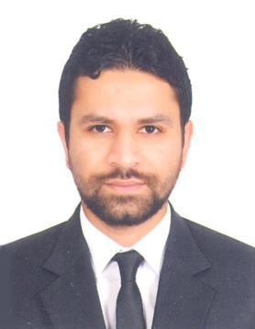
OBJECTIVE:

To do my job to the best of my ability with my knowledge, competence & hard work, hence proving to be an asset to the organization I work in.

PERSONAL STRENGTHS:

Communication & presentation skills, interacting with people, good listener, creative thinking, analytical ability & sincerity in my work

EDUCATIONAL QUALIFICATION:

➢ Higher Secondary Passed in Year 2007-08

PROFESSIONAL PROFILE:
Professional Qualification:
- Diploma in International Airline & Travel Management

- C.R.S. – Galileo, Amadeus & Sabre

- Diploma in Office Application And Designing Technology

- Computer hardware and Networking

- Basics in computer application

WORK EXPERIENCE.

➢ ORIENT TRAVEL & TOURISM AGENCY LLC DUBAI (UAE)
From May 2013 till date
Travel Consultant

- Ensure to confirm availability plus convey tentative itinerary to respective traveler for approval.

- Confirm reservations, distributes tickets along with confirmations to traveler.
- Research on optimal travel alternatives.
- Maintain and update profiles for corporate as well as customer travel.
- Maintain queues to assure approvals as attained as well as deadlines are met.
- Resolve organization travel related technical conflicts.

- Research and resolve all incorrect charges with respected to entire travel program.

- Review travel associated invoices as well as statements for accuracy plus codes for Accounts Payable.

- Ensure to compare invoices with genuine travel transactions to validate every charge.

- Identify most suitable as well as best quality service with reasonable possible rates.

- Verifying travel details and arrange reservations using existing flight schedules as well as Internet resources.

➢ SHREE SATI TRAVELS PVT.LTD (IATA)
From November 2010 to February 2013 (Worked for an Implant) Bank of Baroda
Travel Consultant

- Communicating with the customers for their basic information
- Handling corporate client.
- Issuing & Reissuance of tickets

- TIRUPATI TRAVEL NETWORK (IATA)

From October 2009 to November 2010
Travel Consultant

♦ Communicating with the customers for their basic information ♦ Handling walk in and corporate clients

♦ Issuing of tickets
♦ Handling sub-agents

- ASMI TRAVELS

From November 2008 to October 2009
Travel Consultant

- Communicating with the customers for their basic information
- Handling walk in and corporate clients
- Issuing of tickets
- Handling sub-agents

➢ SHREE SATI TRAVELS PVT.LTD (IATA)
From June 2007 to October 2008
Travel Consultant

- Communicating with the customers for their basic information
- Handling walk in and corporate client.
- Issuing tickets
- Handling sub agents
- Preparing daily reports

