CURRICULUM VITAE  SAJISHA  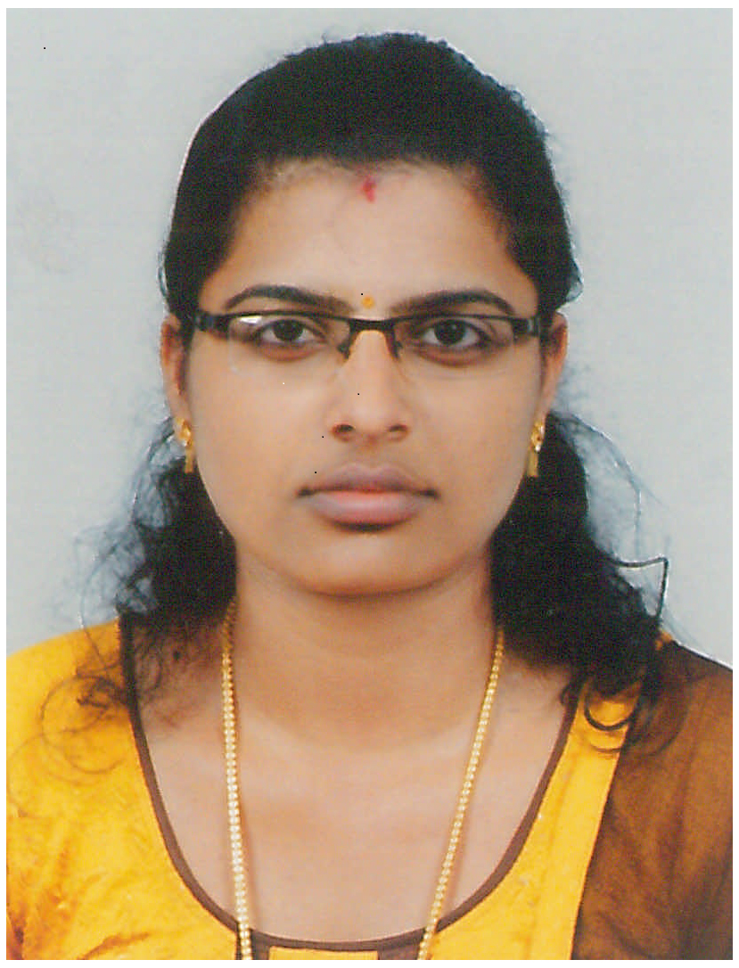  Sajisha.359421@2freemail.com  Visa Status :  Husband’s Visa  Valid till:04/01/2018  Personal Data:  Gender : Female  Date of Birth: 30/11/94  Marital Status :Married  Nationality : India  Current Location: Sharjah  Languages Known:  - English  - Hindi  - Malayalam | Career Objective  Seeking a challenging position where my acquired skills and education will get maximized to the best of my abilities. To associate with an organization where there is an ample scope for organizational growth as well as scope for development of the individual.  Educational Qualification  - Bsc Computer Science from Kannur University, Kerala, India  - Plus Two from Higher Secondary Board, Kerala  - SSLC (10th) from Board of Secondary Education, Kerala  Work Experience  - Worked as a .Net Trainee Software Engineer at Integos Intelligent Solutions, Kannur, Kerala.  Academic Projects  - Developed a Web application for online ICDS Survey for the state govt, using C# Language.  The Project “Online ICDS Survey” has been developed using Asp.Net as Front-End and Microsoft SQL Server 2010 as back-end in Windows 7 Platform. The project aims to develop a web application for social welfare scheme by the govt of India.  Technical Skills  - Operating Systems : Windows XP, Windows 7, Windows 8, Linux  - Languages : C, C++, Java, VC++, PHP, C#.Net  - Applications : MS Office 2003,2007, 2010, Internet  Achievements  - Successfully completed three months .Net certification course.  - Completed three months certification course in PHP.  Strengths  - Self motivated, with good interpersonal and communication skills.  - Ability to take on responsibility and work as a team leader.  - I have the ability to work on Real Time Projects.  Declaration  I here by declare that the information in this document is accurate and true to the best of my knowledge.

