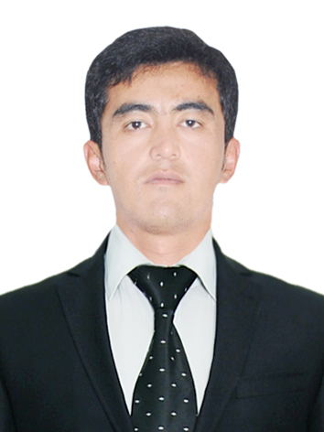
Shavkat
Shavkat.359465@2freemail.com
Personal information
Date of Birth: 1 May, 1990
Age / Height / Weight: 27/ 180 / 80
Place of birth: Uzbekistan, Tashkent city
Nationality/Gender: Uzbekistan/Male
Education background
2010-2014 Gulistan State University. Faculty of English Philology, Uzbekistan
Specialization: English philology
2008 – 2010 Russian high school. Uzbekistan
1999 – 2008 Russian secondary school. Uzbekistan

Computer skills:
Advanced user of PC, Microsoft Windows XP and Far Manager, Microsoft Office, Adobe Reader, Total Commander, Internet explorer, Html and opera, Fidelio, Micros systems.
Language Ability skills:
- English language: Fluent (Spoken, Written, Reading)
- Russian language: Excellent (Spoken, Written, Reading)
- Turkish Language: Fluent (Spoken, Written, Reading)
- Uzbek language – native.
Job experience
January 2016– Current
Miramar Al Aqah Beach Resort hotel. (UAE Fujairah)
Job title: Telephone operator
Responsibilities:
Operate telephone exchanges, PBX machines, intercoms and public address systems
• Take telephone calls from visitors and customers and provide them with required information
• Ensure that information provided to callers is precise and within the boundaries set by company protocols
• Make telephone calls to people upon instructions from company executives
• Transfer telephone calls to concerned departments and individuals
• Enquire as to the nature of incoming calls and exercise judgment to determine importance of call
• Make calls to executives to determine if a particular executive wants to take a phone call
• Operate fax machines to send and receive messages
• Receive messages from callers and relay them to appropriate recipients
• Provide paging services for individuals when requested
• Report any problems or operating issues with telephone equipment
• Perform minor troubleshooting activities on telephone equipment
• Ensure that appropriate telephone equipment maintenance is scheduled
• Keep records of calls and record any calls that are deemed important by the company
• Make sure that irate callers are dealt with in a polite manner
• Update directory information and provide relay services for people with hearing impairments
• Perform filing and record keeping activities and ensure that work areas are kept clean and maintained
December 2014 – December 2015

Hotel Wyndham Tashkent, Uzbekistan

Job title Telephone operator
Responsibilities:
• Operate fax machines to send and receive messages
• Receive messages from callers and relay them to appropriate recipients
• Provide paging services for individuals when requested
• Report any problems or operating issues with telephone equipment
• Perform minor troubleshooting activities on telephone equipment
• Ensure that appropriate telephone equipment maintenance is scheduled
• Keep records of calls and record any calls that are deemed important by company
Objective: I want to succeed in a stimulating and challenging environment, building the success of the company while I experience advancement opportunities.
Personal Qualities
- Quick learner
- Responsibility, Motivation and Dedication
- Ability to work under pressure and adapt to new environment
- Sense of organization
- Multi-tasking, Flexibility
- Good communication skills with high-level customer service

References are available upon request

