Name: NGWA
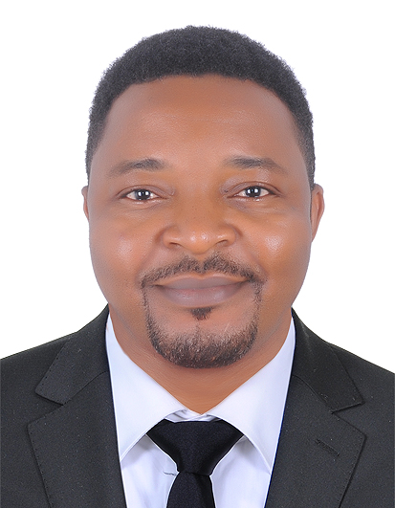
NGWA.359476@2freemail.com

Profile | Highly skilled professional in administrative and operations management with 10+ years experience in the field of teaching in business administration. A Certified Manager with ABMA UK ( Association of Business Managers and Administrators of UK). Highly organized, diligent and responsible, able to create and execute complex projects and programs to meet organization needs. Skilled in multi-functional team collaboration with all departments. Recruited, hired, supervised, scheduled and motivated a staff of up to 146 employees.  Proficient in strategic planning, managing projects, improving efficiency of operations, and team building. Able to identify areas of strength and weaknesses and implement company policies, standards, changes in operation and systems that optimize productivity and achieve the main goal of an organization.  An expert in quantitative analysis and financial management operations, cost control, financial forecasting and budgeting.  Highly trustworthy, ethical and discreet. Strong interpersonal skills and effective collaboration with management, team members and clients.  Proficient user of Microsoft Excel, MS Word, PowerPoint etc
Areas of Competence | - Employee coaching and motivation  - Project coordination management  - Budgeting and operational cost analysis  - Business development and expansion strategies  - Experienced in operations management, sales, budget development, staffing and cost control  - Able to motivate employees to perform to their maximum potential  - Team training and mentoring  - Inventory/ material management  - Supply chain management activities  - Human Resource Management and employees relations  - Production and operations Management  - Quality and productivity improvement  - Marketing Management services
Professional Experience | Name of Company: LANDMARK UNIVERSITY, Cameroon  Position: Programs Manager/Trainer  Duration: 3years (2014/2017)  Responsibilities:  Served as a Management and accounting trainer/lecturer and as the programs director. Supervised daily 124 academic staff and 17 support staff members. The following is a summary of my main duties:  - I assisted the administration to establish and build collaborative working relationships with partner institutions such as ACCA, ABE, ABMA etc  - I identify and Make proposals for the improvement of efficiency and effectiveness in general operations .  - Oversee the budgetary process of the institution and proper allocation of resources to the different units.  - Ensure compliance with the regulations and policies of the Ministry of Education.  - Monitors and implement, regulations, students codes of conduct, Malpractice code, advises the senate accordingly on the necessary changes.  I trained and lectured the following courses:  - Project Management  - Principles of Management  - Managing change, innovation and renovation  - Human Resource Management and employee relations  - Operations and production management  - Customer Relations Management  - Maintaining financial records  - Financial Reporting  - Forecasting, Establishing and reviewing budgets  - Cash Management  - Managing change, innovation and renovation etc  Name of Company: Organization for Life Care, Yaoundé, Cameroon  Position: Accountant  Duration: 4years (2011/2014)  Responsibilities:  I usually Performed a full spectrum of accounting functions for this non-profit organization, administered accounting operations for approximately 15 field project centres.  OFLIC is a non-profit organization. I usually performed a full spectrum of accounting functions for this organization, administered accounting operations for approximately fifteen field projects centres.  Main responsibilities:  - I manage payroll administration on Excel Formatted software system, initiated pay allotments, deductions, treatment of outstation allowances  - Monthly I prepare vat returns and make VAT declaration  - I assisted in the preparation, review of the annual budgets for departments  - I personally manage grant accounting activities, monitor, prepare and submit reports of all financial activity to various grant donors and sponsorship programs  - I usually support program managers and directors with accounting functions, including expenses, invoices and billing issues  - Daily I enter data in the general ledger, and ensuring correct coding for payments are accurate entered in the system.  - Prepare journal entries, working papers and departmental analysis for quarterly and year-end audit  - Participate in accurate and timely monthly closes such as bank reconciliation, revenue analysis, reconciliation of general ledger accounts and preparation of financial statements  - Enter financial data into finance software program, utilize databases, spreadsheets and templates  - Build and format reports in Excel from imported revenue income reports and other financial data  Name of Company: Trustech Higher Institute of Technology, Buea  Position: Cashier/Accounts Clerk  Duration: 4years (2006/2010)  Responsibilities:  - I handle students and parents inquiries and solved billing problems  - I was responsible in processing payments in cash, debts and credit cards  - At the end of each day would count and reconcile receipts with monies collected, prepare tally sheets and deposits  - At the end of each month would undertake the declaration and payments of staff insurance dues to the National Social Insurance Fund  - Issue receipts for fee payments and refunds for over payments,  - Checking daily cash accounts and make daily bank deposits  - Providing training and assistance to students on internship in the cashier department  - Maintaining monthly, weekly and daily report of cash transactions  - Payout staff outstation allowances and other benefits
Educational Background | Current Goal: CPA  Finalist, Certified Public Accountant (CPA) KASNEB Program (2016)  Masters of Business Administration in Accounting and Finance (MBA)  Saint Monica University Buea, Cameroon, ( Dec 2013)  Bachelors of Science in Management (BSc)  University of Buea, Republic of Cameroon (Dec 2006)  Graduate Diploma in Business Management  ABMA Education, United Kingdom (June 2014)  Diploma in Computerized Accounting Systems  TRUSTECH Higher Institute of Technology Buea, Cameroon (Dec 2014)
Technical Skills | - Owns a Drivers License – Driving for two years now  - Advanced skills in Microsoft Excel, Excel programming and Formatting  - Proficient in computerized accounting software:  QuickBooks, SAGE Accounts and Excel Bookkeeping applications  - Advanced Skills in Microsoft Words, Microsoft PowerPoint and Microsoft Publishers  - Knowledge working with database management systems and network applications  - High working knowledge of the internet and related applications
Professional Certifications | - Certified Public Accountant (CPA) Finalist  - Certified Manager (ABMA) UK
Language Skills | - Advanced Communication skills in spoken and written English  - Basic Skills in Spoken and written French
Patents & Publications | Books Published:  - Ngwa, M.S (2010) Cost and Management Accounting Harmonized. Quality printing press, Molyko Buea, Cameroon  - Ngwa, M. S (2012) Business Management Study Guide. Catholic Printing press, Buea Camerooon  - Ngwa, M.S (2014) Principles of accounting for beginners. Google Print Buea, Cameroon  Unpublished books:  - Advanced Financial accounting for Higher National Diploma  - Fundamentals of Supply Chain Management for undergraduate studies  - Production operations and Management for undergraduate studies
Declaration:
I certify that the statements made by me on my CV are true, complete and correct.

