Present
2010

2008 - 2010

2006 - 2008

2004 - 2006

1999 - 2003
ATA
ATA.359478@2freemail.com

WORK EXPERIENCE

Planning & Strategic Manager

Ghantoot Group – Building Division UAE

- Review & analysis periodically monitoring reports for all projects.

- Attend top management meetings to discuss projects status.

- Manage & verify extension of time claims.

- Represent the management in clients/consultants meetings.

Sr. Planning Engineer

Ghantoot Group – Building Division UAE

- Supervise, lead and coordinate projects planning team.

- Prepare master programs complying with contracts.

- Prepare manpower histogram, S-curves, cash flow.

- Assist in identify delay events to prepare the EOT claims.

Planning Engineer

Ali & Sons Contracting Co. UAE

- Prepare preliminary tender programs.

- Preparing two weeks look ahead schedule.

- Prepare monitoring reports including weekly & monthly.

Project Engineer

Engineering and Management Consulting Centre ^{Palestine}
- Project supervision and execution.

- Follow up site engineers and foremen.

- Manage subcontractor’s works.

EDUCATION

Bachelor of Science in Civil Engineering

Islamic University of Gaza Palestine

WHY ME?

Almost 13 years of construction and project management experience in the construction industry,
Leading construction teams of large projects and completing them successfully.
SKILLS
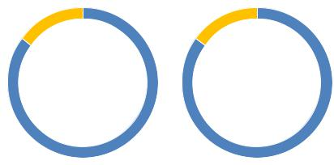
^{Project} Construction
Management _{Field}

Planning & | Claims
Scheduling | Analysis

Contracts Procurement
Administration Management

Microsoft Office
Primavera
MS Project
AutoCAD
Adobe Photoshop
3DStudio Max

 | MAJOR TRAINING COURSES | LANGUAGES
 | Contracts Management under FIDIC 1999 Red Book | Arabic
 |  | English
 | Claims Management in Construction Industry
 | Training Course on Applied Construction Management
 | Estimating and Bidding Strategies
 | Financial Management of Construction Projects
 | IOSH - Institution of Occupational Safety and Health
 | Internal Audit of Quality Management System
 | Internal Audit Course of Environmental Management System
 | Internal Audit of Occupational Health and Safety Management

 | Most Important Projects
 | Project | : | Presidential Palace - Phase I
 | Project Value | : | 1,800,000,000 AED
 | Client | : | MOPA
 | Project Manager | : | RW Armstrong
 | Consultant | : | EWAN
 | Project | : | Presidential Palace - Phase II
 | Project Value | : | 1,100,000,000 AED
 | Client | : | MOPA
 | Project Manager | : | RW Armstrong
 | Consultant | : | EWAN
 | Project | : | Abu Dhabi Court House
 | Project Value | : | 1,200,000,000 AED
 | Client | : | Abu Dhabi Judiciary Department
 | Project Manager | : | Morganti Group
 | Consultant | : | Decospania Interiors LLC & | Inspiration Interiors
 | Project | : Saadiyat Island Resort Development (Five Star Hotel)
 | Project Value | : | 900,000,000 AED
 | Client | : | Sheikh Suroor Projects Department
 | Project Manager | : | Khatib & Alami
 | Consultant | : | Khatib & Alami
 | Project | : | Abu Dhabi Trade Center Extension - Phase 3
 | Project Value | : | 700,000,000 AED
 | Client | : | Sheikh Suroor Projects Department
 | Consultant | : | Khatib & Alami
 | Project | : DAMAC AKOYA OXYGEN (981 VILLAS)
 | Project Value | : | 800,000,000 AED
 | Client | : | Frontline Investment Management
 | Consultant | : | DAMAC
 | Project | : | Al Raha Beach - Residential Development
 | Project Value | : | 500,000,000 AED
 | Client | : | Aabar Properties
 | Consultant | : | Khatib & Alami
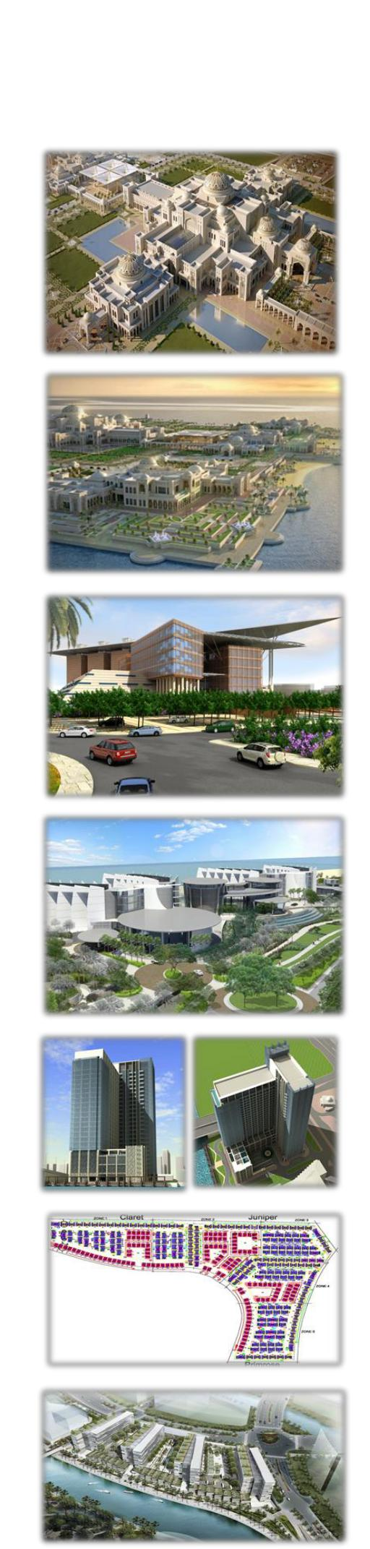

 | Most Important Projects
 | Project | : | Emirates National School & Staff's Accommodation
 | Project Value | : | 500,000,000 AED
 | Client | : | MOPA
 | Consultant | : Heberger Engineering Consulting Engineers
 | Project | : | Supreme Council for National Security Building
 | Project Value | : | 330,000,000 AED
 | Client | : | The Supreme Council
 | Project Manager | : | PMDC
 | Consultant | : | EWAN
 | Project | : | National Rehabilitation Center
 | Project Value | : | 300,000,000 AED
 | Client | : | NRC
 | Project Manager | : | Musanada
 | Consultant | : | HDP
 | Project | : | Office & Residential Tower (4B, Gr, Mz, 28F & R)
 | Project Value | : | 300,000,000 AED
 | Client | : | Tasameem Real Estate
 | Project Manager | : | WS Atkins Overseas & Partners
 | Consultant | : | Office & Residential Tower (4B, Gr, Mz, 28F & R)
 | Project | : Fujairah Intercontinental Hotel (Five Star Hotel)
 | Project Value | : | 250,000,000 AED
 | Client | : H.H Shaikh Hamdan Bin Zayed Alnahyan
 | Consultant | : National Engineering Bureau (NEB)
 | Project | : Abu Dhabi Detainees Building
 | Project Value | : | 200,000,000 AED
 | Client | : Abu Dhabi Judiciary Department
 | Project Manager | : | Morganti Group
 | Consultant | : | Dar Al Omran
 | Project | : Al-Jazeera Tower (3B, Gr, Mz & 34F & R)
 | Project Value | : | 150,000,000 AED
 | Client | : H.E. Dr. Mana Saeed Al Otaiba / ADCE
 | Consultant | : | AL SUWEIDI Engineering Consultants
