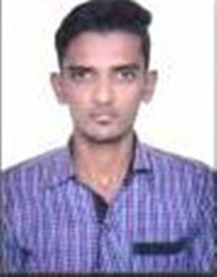
CURRICULUM-VITAE

Name: SHAKEEB
SHAKEEB.359509@2freemail.com
Objective
Seeking a position as an Accountant where my experience and accounting skills will be further developed and utilized.

Key Skills
- Good analytical and problem solving skills.
- Sound knowledge of handling accounting system.
- Ability to sort, check, count and verify numbers.
- Strong ability to use an automated accounting system.
- Good organizational skills.

Professional Experience
1. Working with Shoaib Leathers as Accounts Executive since 4th January 2015 to till date.

2. Worked in a Leather Factory as a Computer Operator since August 2013 to December 2014.

Job responsibilities:-

- Using automated accounting systems for data input and to obtain reports.
- Responsible for maintaining accounting ledgers and performed account reconciliation.
- Maintaining the status of funds.
- Performing account analysis and account research.
- Processing accounting transactions.
- Responsible for expenditure and collection transactions.
- Handling customer inquiries, researched problems and developed solutions.
- Training the junior accounting clerks.
- Researching problems and processed corrected payments.
- Maintaining records of payment information.
- Managing vendor accounts, generating weekly on demand cheques.
- Maintaining track record of company’s expenses.
- Assisting in carrying out company’s internal audit.
- Carrying out various banking functions like online banking etc.

Education
- B. Sc. from B.N.D. PG College in 2014 from CSJM University.
- 12th from U.P. Board in 2011.
- 10th From U.P. Board in 2008

Hobbies
- Playing Cricket
- Listening to Music

Personal Details
Date of Birth : 11th September,1994
Languages Known : Hindi & English
Nationality : Indian
Religion : Muslim

Declaration:
- I hereby declare that all the information furnished above is true to the best of my knowledge.
Place: Kanpur (

