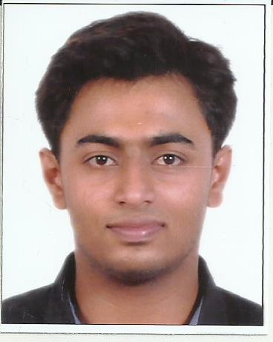
SEBY SEBY.359515@2freemail.com

.

Professional Profile
PROFILE SYNOPSIS

Human Resource Administrator job position where my customer relations skill can be entirely used to improve the reputation of human resources department as well as company. Expertise encompasses operational services, performance management, recruitment and employee relations. Graduate Indian national with academic base in Bachelor of Science. Total of three Years (2years in Oman) of experience in Administrative, Human Resources and Customer service posts with certain reputed companies in India and Abroad. Good work experience in Windows, M S Office.
CORE COMPETENCIES

1. Good Communication Skills.
2. Client Service.
3. Business Understanding
4.Team Player
5.Technical Skills
6.Organizational Management

s
Geometric Ltd.
CAREER CONTOUR
Assistant Administrator from July 2013 to August 2014.
Fahud Line Trade & Transport Ltd.
Assistant HR executive from October 2014 to October 2016.
DOMAIN SKILLS

*Provide current and prospective employees with information about policies, job responsibilities, working conditions, wages, opportunities, for promotion and benefits.
*Maintaining employee records like annual leave, personal leave, sick leave etc.
*Time administration through Biometric profile and payroll finalizing.
*Maintain records and compile reports concerning personnel related data such as hires, transfers and absenteeism rates.
*Identify vacancies and select applicants.
*Performed support activities for multiple supervisors.
*Greet clients and guests and decide whether they should be given the right of entry to meet specific individuals.
*Accountable for organizational and clerical duties that is essential to run an organization.
*Handle phone calls and relay messages to appropriate department or individual.
*Oversee office's filing and record management needs.
*Prepare administrative report for senior managers.
*Handle administrative issues and conflicts as per company's policies.
*Prepare memos, invoices and reports through word processing, spreadsheet, database, and presentation software such as power point.
ACADEMIC PROJECT WORK

Project: Hostel management System - Software: Front end-visual basic, back end-MS access
Final year Project: Airline Reservation system - Software: Front end-visual studio 2010, Back end-Sql.
Electronic final year project: Automatic room light controller with visitor counter.
ACADEMIC CREDENTIALS
Bachelor of (Computer Science, Mathematics, Electronics) (BSc) Kristu Jayanti College , Bangalore, India.
Pre-University Class –Holy Angels College, Mumbai, India.
SSLC - Holy Angels College, Mumbai, India.
TRAININGS & CERTIFICATIONS

1st Prize in Project exhibition inter collegiate Electronics Fest Organized by Christ University Circuit 2012.
Certification of merit for successfully completing Basic Web designing course 2010.
Certification of participation for completing Basic Robotics workshop organized by Tech –a-comp.
Certification of participation for science exhibition Galaxia 13.
COMPUTER SKILLS

OPERATING SYSTEM: Windows 7, Windows Xp , Windows 8, Windows10.
Office Applications: Microsoft Office 2003,2007/2009/2011,Power point 2007, Microsoft word, Excel.
Programming language: C, C++,Java, Unix, HTML.

