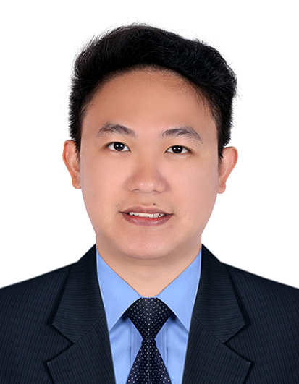

JOHN
JOHN.359516@2freemail.com

SUMMARY:

Accounting graduate with 4 years of experience. My goal is to be part of a company or institution that will enhance my knowledge and will provide working experience, opportunity for professional development and career growth as a prospective member of the industry.

PROFESSIONAL EXPERIENCE:

JSETH Real Estate Consultancy
Jr. Accountant
January 2015 – November 2016

Responsibilities:

- Record and prepare journal entries for daily transactions.
- Assist in the preparation of FS.
- Follow-up collections with clients.
- Process Payroll.
- Prepare and update collection record.
- Update & file official receipt.
- Record and update daily disbursements.
- Monitor and update petty cash voucher.
- Prepare weekly budget.
- Prepare tax report.
- Prepare monthly cash reconciliation.

Banco De Oro Unibank, Inc.
Accounting Assistant
December 2012 – January 2015

Responsibilities:

- Record and post daily transactions.
- Assist in preparation of monthly branch level FS.
- Prepare year end adjusting entries.
- Monthly checking and balancing of supplies inventory.
- Prepare transaction slips for payment of daily expenses.
- Prepare check for payment of monthly expenses.
- Prepare and issue official and acknowledgement receipt.
- Prepare CASA report.
- Prepare time deposit and other investment report.
- Prepare cash position (Daily & Monthly).
- Prepare teller’s proof (Daily).
- Prepare daily and monthly report.
- Check and file transaction slips.
- Batching and vouching of teller’s daily transaction.

EDUCATIONAL BACKGROUND/ACHIEVEMENTS:

2007 – 2012 Graduate, B.S. Accountancy, Adamson University, Manila Philippines

KEY SKILLS:

- Proficient in basic computer programs: Microsoft software (MS Word and MS Excel).
- Good written and oral communication skills.
- Ability to multi-task in a fast-paced environment.
- Able to perform task even under pressure.

ORGANIZATIONS/AFFILIATIONS:

- Junior Philippine Institute of Accountants –Adamson University Chapter (2011-2012),P.R.O
- Banco De Oro Unibank, Inc. – Reposo Branch (2013-2015) Branch Steward

PROFILE;

AGE: 26
BIRTHDAY: May 13, 1990
GENDER: Male
CIVIL STATUS: Single
CITIZENSHIP: Filipino

