Hey, This is Designer and Front-End Web Developer. I produce awesome designs for mobile and web platform. I love to bring ideas to life with the touch of great design. I'm a challenge taker who loves to keep trying till the last hour to win the challenge.

My aptitude to observe nature in its purity and environmental behavior always kept me driving my mind at optional thinking to Draw. Truth / reality helped me a lot to be the professional Web Developer. I got ability to design Websites as per custom desire and information of the subject provided.

To acquire maximum of creativity I always learn from my mistakes having quest to exceed Client’s expectations.

EDUCATION
2008 | 2011 | 2013 | 2015
MATRICULATION | I-C-S | B-C-S | M-C-S
SARGODHA BOARD | SARGODHA BOARD | SARGODHA UNIVERSITY | NUML ISLAMABAD

SKILLS
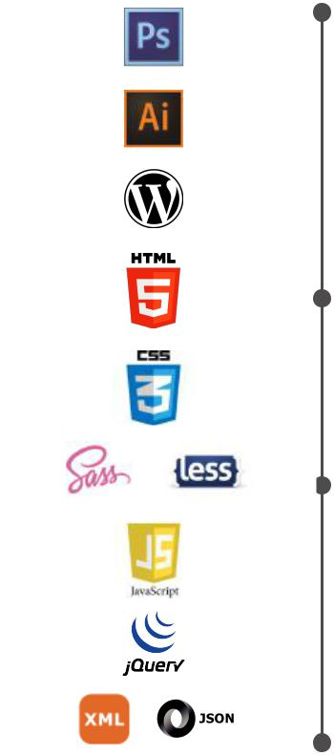
ADOBE PHOTOSHOP
ADOBE ILLUSTRATOR
WORDPRESS
HTML5
CSS3
SAAS& LESS
JAVASCRIPT
JQUERY
XML & JSON

Experience

GRAPHIC DESIGNER as a Freelancer

More than 18 Months I worked as a freelancer Graphic Designer. In this period I have experienced different types of designs like Logos, Flyer, Business Cards, Web Templates, Web Buttons and a lot more.

ACCOUNTANT at The Creators Printing System

From Jan 2016 to Oct 2016

PROGRAMMING SKILLS

C++ PROGRAMMING |  | PHP
JAVA DEVELOPER |  | SQL SERVER
C# AND ASP.NET DEVELOPER |  | DATABASE DEVELOPMENT
WEB PROGRAMMING |  | ORACLE

WORDPRESS PLUGINS AREA

I have done many freelancing projects using these wordpress plugins and having good commands over these.

SLIDER
REVOLUTION

Royal Slider
VISUAL COMPOSER
WOOCOMMERCE

SLIDER REVOLUTION RESPONSIVE

ROYALSLIDER(TOUCH CONTENT SLIDER)

SEO BY YOAST

WPFORMS

JETPACK

SITEORIGIN PAGE BUILDER

Google XML Sitemaps

WRAPPING UP
THEMIFY BUILDER

GOOGLE XML SITEMAPS

WORDFENCE SECURITY

MAILCHIMP FOR WORDPRESS

SOCIAL ICONS

DISABLE COMMENTS

WRAPPING UP

W3 TOTAL CACHE

PRACTICING AREAS

FRONT-END DEVELOPMENT |  | WIREFRAMING
WordPress |  | RESPONSIVE WEB DESIGN
PROTOTYPING |  | CODE QUALITY TESTING
UNIT TESTING |  | CODE COVERAGE TESTING
CROSS-BROWSER TESTING |  | CODE COMPLEXITY ANALYSIS
CROSS-PLATFORM TESTING |  | INTEGRATION TESTING
CROSS-DEVICE TESTING |  | TEMPLATING STRATEGIES
USER EXPERIENCE |  | TEMPELATING ENGINES
E-COMMERCE SYSTEMS |  | SINGLE PAGE APPLICATIONS
LANGUAGES
ENGLISH
URDU

References will be provided on demand.

