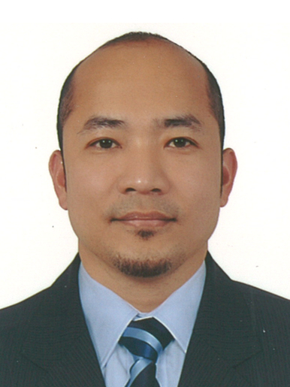
MARK
Email: mark.359567@2freemail.com

Work Experience

Finance House
Personal Finance Officer
December 06, 2016 – Present

- Generating client for Personal Loan and Credit Card for salaried employees across UAE.
- Describing the characteristics, rewards, and risk of any particular security
- Maintaining harmonious relationship to the client in preparation for future business endeavors.
- Establishing credit worthiness of high profile and high risk applicants.
- Marketing specified area to deliver numbers by doing office-to-office visits and cold callings.
- Perform excellent customer service to attend clients’ needs and queries.

Dunia Finance LLC, Dubai, UAE
Relationship Officer (Loans)
December 30, 2014 – September 28, 2016

- Responsible in generating client for personal and auto loan for salaried employees across UAE.
- Establishing / maintaining harmonious relationship to the client in preparation for future business endeavors.
- Establishing credit worthiness of high profile and high risk applicants.
- Marketing specified area to deliver numbers by doing office-to-office visits and cold callings.
- Perform excellent customer service to attend clients’ needs and queries.

Citibank N.A. Philippines – Quezon City
Credit Adviser (Credit Cards)
March 15, 2011 to November 10, 2014

- Establish effective rapport with debtors, responsible relatives and other parties to obtain information and elicit cooperation.
- Understand, apply and explain pertinent laws and procedures concerning collections.
- Learn computer applications and to accurately input and access information on an on-line, real-time system.
- Communicate effectively in oral and written form.
- Negotiate agreements and settlements within established guidelines.
- Independently evaluate information and initiate action within prescribed guidelines.

Citibank Savings Inc. Philippines – Quezon City
Credit Adviser (Personal Loans)
October3, 2007 to March 14, 2011
- Communicate effectively in oral and written form.
- Establish effective rapport with debtors, responsible relatives and other parties to obtain information and elicit cooperation.
- Understand, apply and explain pertinent laws and procedures concerning collections.
- Learn computer applications and to accurately input and access information on an on-line, real-time system.
- Independently evaluate information and initiate action within prescribed guidelines.

AXA Philippines - Makati
Customer Care Officer
February 12, 2007 to August 3, 2007
- Receive incoming calls from client and agents for Reinstatement Process
- Monitor and Track reinstatement request from client
- Verification of documents receive to check if qualified
- Call client/agent for no payments and with health problems
- Mailing of confirmation letter to those approved and enforce policies
- Process transfer of policies to once agent with regards to the area

AXA Philippines - Makati
Receiving Clerk
February 10, 2006 to July 30, 2006
- Receiving of document and have it forwarded to the processor
- Releasing of Loan check, Surrendered Policy, and other Refund policy to client
- Preparation of all the checks to be mail to policy holders
- Monitoring of all returned checks for strict compliance
- Encoding of received document for proper monitoring

Asianlife Financial Assurance Corporation
Loans Reivable Assistant
October 16, 2004 to February 8, 2006
- Monitoring of past due accounts per Region every month
- Encodes new business transactions for system applications
- Preparation of Breakdown by Division and by category
- Posting of payment thru system and printing after posting
- Preparation of Statement of Accounts

Phillippine Ports Authority - Batangas
Collection Assistant
February 1, 2001 to September 30, 2004
- Prepare Report of Collection every end of the Shift
- Remit the collections to the Port Cashier
- Document all collections inventory every the month
- Post all collections receivables to CASH BOOK
- Monitor all receipts and cash tickets and return it to Finance Department

Education
Bachelor of Science in Computer Science(1996 – 2000)
University of Batangas
Hilltop Batangas City

Seminar Attended
- Local Area Networking and Internet Seminar (February 13,1997)
- HTML Web Design (May 18,1999)
- A New Frontier on Y2K (July 24, 1999)
- Structured Cabling System (September 19, 1999)
- I.T. Updates and Basic Networking (January 27, 2000)
- Signature Verification Seminar (July 10, 2007)
- Basic Collection Course (December 2008)
- Ultimate Secrets Collections course (December 2008)

Personal Details

Name: Mark
Nationality: Filipino
Date of Birth: 5 May 1979
Marital Status: Married
Visa Status: Residence Visa

CERTIFICATION

I hereby certify that the above information is true and correct according to the best of my knowledge.

Mark
Applicant

