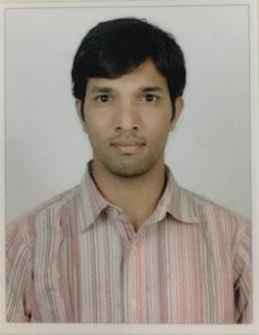
SANDEEP , CPC Certified (01400680)
Mobile No: C/o 971501685421
E-Mail: sandeep.359574@2freemail.com
Passport
Date of Issue : 19/02/2010
Date of Expiry : 18/02/2020

Career objective:
To pursue socially responsible entrepreneurship by constantly encouraging innovation within the organization and there by paving way for quality and accuracy in risk adjustment. Delivering the files in time by maintaining the quality and quantity equally at high importance.

Qualifications:

- Completed BscMLT from Shadan Medical college ,NTR health University, Vijaywada.
- Completed Intermediate from SMR Junior College, Hyderabad.
- Completed SSC from Little flower High School, Hyderabad.

Professional Experience:

- 3 yrs experience in E&M and lab pathology, Team Lead. Medical Coder (Hinduja Global Solutions).
- 2 yrs experience in Radiolagy CODING, Medical Coder Apollo Health street (sutherland global services).

My roles & Responsibilities:

As a Team Leader –

Responsibilities:
- Mentored a team of 4 QAs and 20 Coders.
- Developed a strategy the team will use to reach its goal.
- Provided any training that team members needed.
- Monitored team member’s participation to ensure the training provided is being implemented, and also to see if any additional training needed.
- Communicated clear instructions to team members with regard to client and management requirements.
- Encouraged a two-way open channel of feedback.
- Managed the flow of day-to- day operations.
- Created reports to update the company on the team’s progress.
- Developed performance dashboard for the senior management on the team performance.

As a Medical Coder –
- Analyze medical records carefully and appropriately code all the necessary diagnoses and procedures performed by the provider.
- Collect the PHI from the medical records as dictated by the provider and the them appropriately.
- Clarify with the Providers for further information and understanding of items on patient charts to avoid any misinterpretations.
- Attend the internal training programs as well as meetings for the updation on coding rules and client specific rules.
- Aware of and attend the regular meetings on the maintenance of privacy and security policies, according to HIPAA.

Additional Skills:

- Good Communication skills.
- Internet browsing ability to fetch related data.
- Interpersonal relationship skills.
- Event management skills.
- Team motivational and development skills.
- Good analytical skills.

Achievements:

- Acquired 76% in CPC Certification Exam, AAPC on 24th July 2016.
- Was addressed as Top Gun Award for Best Team Lead
- Was addressed with Best Employee Award for consistent Performance and Quality of Coding (HGS).

Personal Dossier:

Date of Birth - 14/08/1984
Nationality - Indian
Gender - Male
Marital status - Married

Declaration:

I hereby declare that the above stated information is true to the best of my knowledge and belief.
Place: Hyderabad.
Date :

(Sandeep)

