.

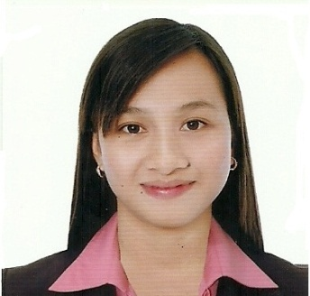

SARAH
SARAH.359637@2freemail.com

CAREER OBJECTIVES

Seeks position which will allow to utilize developed analytical and problem-solving skills as well as thorough understanding of accounting software.

WORK EXPERIENCE

Accountant/Bookkeeper, Saviour Rural Bank Inc,. Sta Cruz. Lubao, Pampanga (Head Office), Philippines
May 25, 2015 to April 15, 2016

- Input daily transactions and subsequently records to the respective subsidiary ledger.
- Preparation of daily cash position.
- Collects daily various bank statements and reconciles the same with subsidiary ledger.
- Reconciling intercompany transactions.
- In-charge on government reportorial requirements of the Company.
- Performs other task as may be assigned from time to time by the immediate superior.
Bank Teller, Saviour Rural Bank Inc,. Poblacion Floridablanca Pampanga (Florida Branch), Philippines
August 04, 2014 – May 22,2015

- Receiving deposits and withdrawal transactions.
- Receiving remittances to government payments.
- Handles encashment of on-us cheques.
- Preparation of daily transaction reports.

Front Line Assistant, Petnet Inc,. (Western Union), Maligaya Street, Sindalan City of San Fernando Pampanga, Philippines
July 31,2013 – April 30,2014

- Receiving deposits and withdrawal transactions.
- Process effective online money transfer.
- Process payments from customers for utility bills such as water, electric & telephone and credit card payments.
- Handle foreign currency exchange transactions.
- Preparation of daily transaction reports.
  - Manage petty cash and prepare reports
  - Organize and maintain filling system of the branch

EDUCATION

Mary the Queen College (Pampanga) Inc.

Bachelor of Science in Business Administration
Major in Financial and Management Accounting

Jose Abad Santos Ave. San Matias, Guagua, Pampanga, Philippines
2009 to 2013

AFFILIATIONS

- Member of National Federation of Junior Philippine Institute of Accountants(NFJPIA)
(2009-2013)
- Working Committee, Junior Philippine Institute of Accountants Region 3 – MQC Local Chapter.

SKILLS/ABILITIES

- Computer literate in Microsoft Office applications.
- Multi-tasking and able to work under pressure with less supervision

SEMINARS ATTENDED

- Genuine and Counterfeit Money Detection (Philippine Peso & US Dollar)
Petnet Inc, Head Office Legaspi Village, Makati City
September 29,2013

- Bayad Center
Petnet Inc,. Head Office Legaspi Village Makati City
February 27,2014

- Countryside Financial Institutions Enhancement Program
Briefing on Financial Reporting Package (FRP) / Capital Adequacy Ratio (CAR) Reporting
BSP San Fernando Branch, City of San Fernando Pampanga
July 30 & 31,2015

PERSONAL DATA

Date of birth: | March 21, 1993 | Height: | 5'1"
Civil Status: | Single | Weight: | 118 lbs.
Gender: | Female | Religion: | Roman Catholic
Nationality: | Filipino

