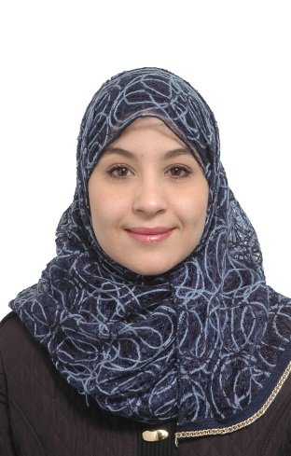

Professional Experiences

Insurance Company

Sales and Customer service/production agend/underwriting insurance 2012-2014

• Investigate and resolve customer’s complaints and queries Resolve 90% of cases

• Handling customer complaints & Inquires

• Initiate conversation to uncover customers' needs

• Maintaining ethical behaviour at all times.

• Answering confidently all kind of clients enquires in an ethical and informative way through e-mails or through the phone or direct contact, to keep their trust

MAMRIA
Date of birth :08/16/1989
e-mail : mamria.359641@2freemail.com
Nationality: Algerian
married

• Create projects to insure the improvement of customer service satisfaction.

• Participation in the organization of a press conference. Planning and organizational skills

• Participation in the negotiation. Customer Contact Centre
Languages:
- Arabic (Mother Language)
- English
- French
Key skills
- Computer literate, Microsoft office (Word, Excel , PowerPoint) & Internet, Act
- Able to work independently under pressure
- Able to learn new things in short span of the time
- Strong sales and customer service and communication knowledge and experience
- Ability to communicate with clients at senior executive and higher management level
Ability and willingness for travel
Business/ Marketing/ Communication /Multitasking
Education And Training
2013-2014 Baccalaureate in Literature and Philosophy(the second baccalaureate).
2008-2012 Law Diploma (Legal and Administrative Sciences); Faculty of Law Batna-Algeria.
2010 Certificate from (ILO) International Labour Office; Training about “How To Manage Your Business”.
2006/2007 Baccalaureate in Literature and Human Sciences SallahEddineElayoubi High School Batna Algeria.
It skills
•Power Point presentation design
•Maintenance, network
Very good command of Office software (Word, Excel, PowerPoint, Outlook
Business/ Marketing/ Communication /Multitasking

