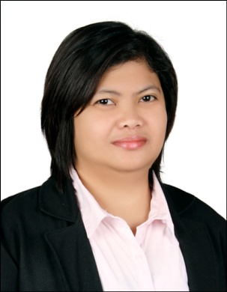

Joanne
Joanne.359685@2freemail.com

Profile:

Experienced in different field of Accounting for nine (9) years in different kinds of Industry. Proficient in communicating using the English language since it is the medium of language used when I was still employed in a BPO. Can work under pressure and with less supervision. Team player.

Career Objectives:

To enhance my ability and skills in a more advance and competitive field of training. To excel in carrying out a task with high level of efficiency and competency. To develop and implement ideas that will help to improve the quality of work in organization and to experience the dignity of work through dedicated service to the company.
Educational Attainment:

Tertiary Annunciation College of Bacon Sorsogon Unit Inc
Bachelor of Science in Accountancy
2002-2006
Skills and Qualifications:

- Proficient in English Language oral and written.
- Advance Microsoft Word, Excel and Power point.
- Accounts Payable (SAP)
- Accounts Receivable (SAP)
- General Ledger Posting (SAP)

Profesional Experiences:

- September 2015- August 2016 Finance & Accounting Analyst IBM GLOBAL BUSINESS SERVICES
Responsibilities:
- Handles 2 processes in SAP
- Procure to Pay Process (P2P)
- Record to Report Process (R2R)

- April 2011 – April 2014 Accounting Staff
LEMCON NETWORKS (Phils) INC
Responsibilities:
- Prepare and maintain subsidiary ledgers.
- Review and finalize book of accounts.
- Prepare financial statements.
- Handles Petty Cash Fund
- Prepares sales invoice and monitor receivable aging.
- Prepares statement of accounts.
- Handles cash receipt/check collections for deposits; prepares OR for cash transactions.
- Prepares and monitor accounts payables.
- Prepare checks and payment vouchers.
- Prepares Check Vouchers
- Prepares report Input Vat/Expanded Withholding Tax

- May 2010 – October 2010 Project Assistant
LEMCON NETWORKS (Phils) INC
Responsibilities:
- Document Controller for my assigned region.
- Time keeping and payroll.
- Handles Administrative task.
- Take down minutes of meeting.
- Handles financial transactions of my assigned region.
- Performs accounting transactions.

- August2008-May2010 Accounting Staff
QUEST-AIRTECHPHILSINC
Responsibilities:
- Prepare and maintains book of accounts.
- Prepares and maintains subsidiary ledgers.
- Handles Petty Cash Fund
- Handles cash receipt/check collections for deposits; prepares Official Receipts for cash transactions.
- Prepares sales invoice and monitors accounts receivable aging.
- Review / process sales invoices from suppliers and monitors accounts payables aging.
- Prepares check and payment vouchers.
- Prepares Input Vat / Expanded Withholding Tax

- March 2007 - July 2008 Accounting Staff
SK Industry Inc
Responsibilities:
- File / Process Govt. mandatory reports
- Preparation of Statement of Accounts per customer
- Recording books of Accounts: Sales book and its subsidiary ledgers
- Follow up collections (as per collection schedule)
- Preparation and replenishment of Petty Cash

- August 2006– February 2007 Warehouse Clerk
LEE OUTFIT CORPORATION
Responsibilities:
- Daily inventory of finished goods.
- Prepare daily packing report to monitor Daily Packing Status.
- Receiving for imports.
- Checking Loading Plans for Exports
- Encoding of all the documents for references

I hereby certify that the above information given is correct according to the best of my knowledge.

