CURRICULUM VITAE
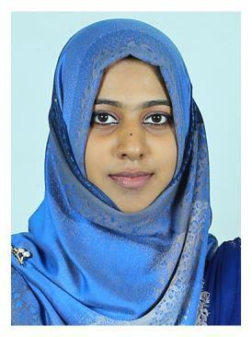

RAMSI.359733@2freemail.com

RAMSI.

C A R E E R O B J E C T I V E

To realize, develop and update one’s potential in the areas of Accounting and to work as a member of a team for achieving organizational and personal goals.

P R O F E S S I O N A L Q U A L I F I C A T I O N S

Graduate from Calicut University in Bachelor of Commerce

P R O F E S S I O N A L S U M M A R Y

Basics:

Accounting Software:

Designing:

MS office, word, excel

Tally

Adobe Photoshop, Coral Draw.

E D U C A T I O N A L Q U A L I F I C A T I O N

QUALIFICATION | NAME OF COLLEGE | UNIVERSITY/BOARD | YEAR OF | PERCENTAGE
 |  |  | PASSING | SECURED
B COM | B.I.M.T. College | Calicut University | 2016 | 57%
 | CALICUT
PLUS, TWO | H.S.M.H.S.S TANUR | Kerala HSE Board | 2012 | 67%
SSLC | RAERIMANGALAM | Kerala Public | 2010 | 63%
 | TANUR | Examination Board

S O F T S K I L L S

- Hard working

- Punctual

- Sincere

- Adaptive

- Explorative

- Convincing

H O B B I E S

- Listening to Music

- Drawing

- shuttle

P E R S O N A L D E T A I L S

Sex

Marital Status

Date of Birth

Nationality

Visa Status

End Date

State

Languages Known

D E C L A R A T I O N

- Female

- Married

- 20-08-1995.

- Indian

- visiting

:may 2017

- Kerala

- English, Malayalam. (Writing, Reading, Speaking),Tamil

I hereby declare that the above written are true to the best of my knowledge and belief.

01/12/2016

