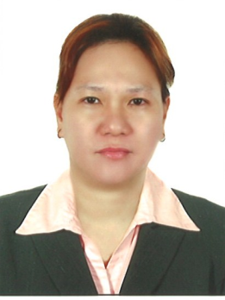

JENNIFER
JENNIFER.359782@2freemail.com

OBJECTIVES
To obtain a position where my abilties and potential can be fully and effectively utilized and develop my skill along within is to contribute my best performance for continuous growth of your well–established company.

PERSONAL ATTRIBUTES
I’m very punctual and cooperative .I can offer my full loyalty and honesty when it comes to work and through personal matters. I have the ability to communicate with efficiency to people with all ages. And I’m very much wiling to learn further development of career.

WORK EXPERIENCE:
Biorganic Store
I Rise Tower. Tecom Dubai Internet City
Cashier
Sept. 2 2016- March 31, 2017
- Having good customer service skills to maintain a friendly environment and treating the customers properly.
- POS knowledge receiving cash floats and sending report at the end of the day
- Answering phone calls deliveries and customers concerns.
- Counting out the exact change and giving the customer a correct legitimate receipt for their order.
- Answering the questions asked by the customers, and if in doubt, directing the customer to the right person.
- Patiently handling the customer queries.

Auditing Staff
J&C Lucky Management INC
June 2011- June 2016

- Prepare, analyze, and verify annual reports, vouchers, invoices, sales report summary , and other records,
- Using statistical procedures to assess financial condition and facilitate financial planning.

Assistant Manager
J&C Lucky 99 Store
Candelaria Quezon Philippines
2009-2011

Duties and Responsibilities

- Welcome incoming customers.
- Undertake the full responsibility of assisting the customer regarding the product lines.
- Promote the products for fast disposal of sales.
- Participate in stocktaking.
- Advise customer on the location and selection of goods available from store.
- Assist in the promotion of products and give prices and details to customer.
- Keep and record all the inventory items on up to date basis
- Mainly responsible in keeping records and transacions done by the customer and the company.

SM Shoe Mart Philippines
Sales Clerk
Section Ladies Apparel
2001 – 2009

- Provide Customers with product information that they need
- Respond to Customers request and concerns in a resourceful manner
- In Charge in taking care of all the stocks in the warehouse
- List all the delivered items in the company.
- Keeping all incoming and outgoing receipt.
- Maintain the cleanliness of the stores
Anticipate the client needs and provide appropriate solution to meet these needs

PERSONAL DATA
Date of Birth: October 19, 1980
Age: 36 yrs. old
Nationality: Filipino
Gender: Female
Civil status: Married
Visa status: Cancelled Visa
Visa expiry: May 10, 2017

EDUCATIONAL BACKGROUND

TERTIARY: Lyceum of Batangas Philippines
(SY.1997_2000)
SECONDARY: San Pablo College Philippines
(SY.1994-1997)
PRIMARY: San Pablo Chung Chua School
(SY.1988-1993)

