CURRICULUM VITAE
Mlle. SEGHIR  SEGHIR.359792@2freemail.com | 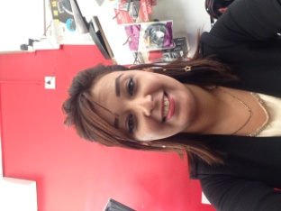

DIPLOMA:
Bachelors: "Literary language" series obtained in 2006
License: Italian language French interpreter
Obtained in June 2012 from BLIDA University
Diplôma: Obtained 01/04/2008 computer initiation office + internet

•professional career
2012: Turkish restaurant LA CASBAH (receptionist) Italian customer service
2013: sales assistant SARL-AMOUR general food products
2014: to date: COMMERCIAL RESPONSIBLE East Samsung Sonny Import
Answer the phone in a polite and professional manner
Obtain and enter information in a specific way "address. Phone number .Email.......... "
Ability to demonstrate good customer service experience 5 years

•Language skills:
Arabic: Very well spoken written
French: Very well spoken written
English: well-spoken written
Italian: Very well spoken written

• ADDITIONAL INFORMATION:
Serious. Dynamic. Sense of responsibility. Punctual. Team spirit and sense of service. Available……

