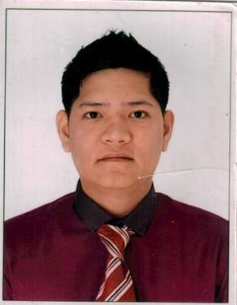
RAYMOND

RAYMOND.359795@2freemail.com

QUALIFICATIONS:
Has a good leadership skill, fast learner, willing to learn new opportunities for advancement, goal-oriented, outgoing with positive attitude, has a strong sense of responsibility and self-motivated.With strong organizational skills, creativity, flexibility, very keen to detailsand has efficient working habits.

WORK EXPERIENCE:

Position: Sales Representative/ I.T Technician
Wardat Al Mizhar Computers
August 2011 to present

Job Description:

- Presents, promotes and sells computers, tablets, other related products or services to existing and prospective customers.
- Sets up individual or company workstations with computers and necessary devices
- Checking computer hardware (HDD, mouses, keyboards, etc) to ensure functionality
- Installs and configures appropriate software and functions according to specifications
- Provides orientation and guidance to users on how to operate new software and computer equipment
- Perform troubleshooting to diagnose and resolve problems (repair or replace parts, debugging, etc.)
- Identify computer or network equipment shortages and place orders

Position:I.T. Representative
Colegio de San Augustin Binan, Laguna
October 2010 to January 2011

Job Description:

- Point contact to school IT matters
- Helps school teachers, students and clients over technical issues.
- Assists in handling IT technical cases in relation to school unit.
- Authorizes and allocates usernames for school unit staff
- Operational duty for creating accounts on particular systems for school unit staff and non-taught course students

Position:Marketing / Sales / Junior Technical Officer
Ncomputing Philippines Inc. Ortigas, Pasig City
March 2009 – January 2011

Job Description:

- Product marketing through telecommunications to encourage client’s growth by choosing software solutions to address organizational needs.
- Setting out and demonstrating product proposals to prospective clients.
- Provides an appropriate technical service for the benefit of clients and colleagues.
- Responsible for maintaining good relations with existing clients.
- Solves and troubleshoot problems related to computers.
- Planning, designing and implementing computer network.
- Installs software and connecting various computers in the networks to transmit data.
- Troubleshoot and diagnose hardware problems, computer repairs and desktops at different establishments.
- Network cabling infrastructure

EDUCATIONAL BACKGROUND

School/ University Inclusive Dates

Tertiary Level: Bachelor of Science in 2004- 2006 Business Administration
PSBA College
Cubao, Philippines

Secondary Level: Roosevelt College 1999- 2003
Cainta, Cainta Rizal

PERSONAL INFORMATION:

Age : 31 years old
Date of Birth : November 18, 1985
Place of Birth : Marikina City
Civil Status : Married
Citizenship : Filipino
Height : 5’10”
Religion : Christian

