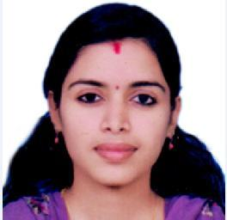

GEETHISRY

GEETHISRY.359802@2freemail.com

Career Objective

To associate with in a dynamic organization, where I can put forth my abilities and knowledge

towards the growth of the organization as well as my career.

Academic Qualifications
- MSc in PHYSICS with 73% of marks from Kannur university, Kerala (2013-2015)

- BSc in PHYSICS with 84% of Marks from Kannur University, Kerala (2010-2013)

- Plus Two with 80% of marks Under Kerala State Board (2008-2010)

- SSLC with 92% of marks Under Kerala State Board (March, 2008)
Career Profile

- OFFICE ADMINISTRATOR AT KOOLIKKAD GENARAL TRADING CO KANHANGAD,KASARAGOD(2016 MAY to 2017 JAN)

- Provided comprehensive administrative support to Foundation managers and staff

- Greeted visitors and answered busy multi-line phone system

- Participation in team meetings and preparing reports.
.Academic Project:

- Synthesis of carbon nanotubes from IISER Trivandrum(Indian Institute of Science Education and Research)

- Optical switches

Software Proficiency

  - Computer languages such as C++,C,VB 6.0,FORTRAN

  - Good Excel knowledge

- Proficient in Windows Operating system

- Expertise in Microsoft software packages such as Word, PowerPoint, and Excel etc.

- DBMS packages MYSQL Server

- Also able to handle general software

- Internet Knowledge

Strength & Qualities

- Confident communication

- Good Presentation Skill

- Team worker and Cooperative

- Ability to learn and adapt.

- Good Interpersonal skills

- Language Expertise in English, Malayalam & Hindi.

Personal Information

Nationality: Indian

Date of Birth: 13-07-1992

Marital status: Married

Declaration

I hereby declare that information furnished above is true to the best of my knowledge and belief.

