HOWARD
Howard.359936@2freemail.com
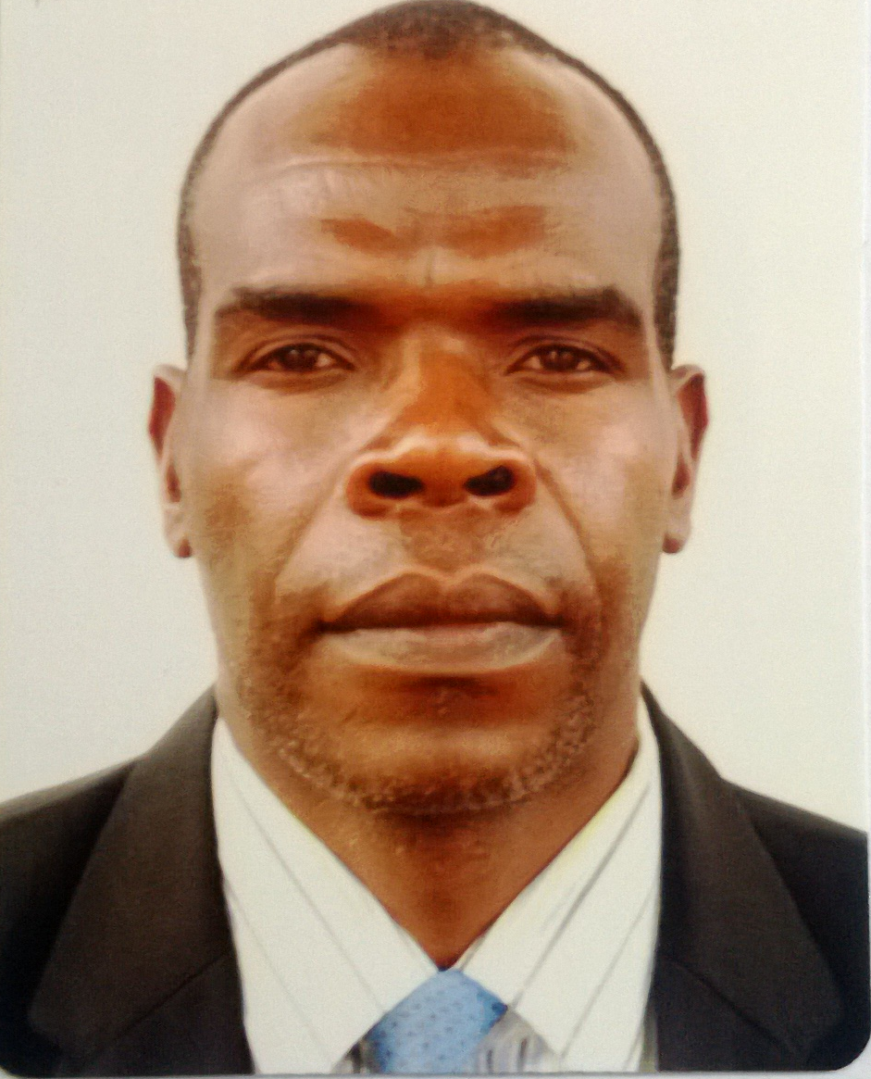

EDUCATIONAL PHILOSOPHY
To transform society by imparting scientific knowledge and science process skills to children through learner centred teaching methods rooted in the modern constructivist learning theory. Every child has the potential to excel with the right differentiated teaching strategies that stimulate his/her intellectual growth.

ACHIEVEMENTS AS SCIENCE (Physics) TEACHER IN SOUTH AFRICA & ZIMBABWE
- 2008-2016 Grade 12 Physical Sciences results ranged above 85 % . I got an award in 2012 and 2014 in the best district science results category -- *South Africa*
- 2011-16; Cambridge IGCSE and A Level Physics pass maintained above 93 % for the *International Students Programme*. *South Africa*
- 2010-16; I Was recommended into the district team of best Science teachers under the Kutlwanong Centre for Maths; Science and Technology project as a physics tutor.

TEACHING LICENCE: SOUTH AFRICAN COUNCIL OF EDUCATORS (SACE)
Licenced to teach General Science (Gr 7-9) and Physical Sciences (Gr 10-12 / A level)
TEACHING SKILLS:
- Differentiated lesson delivery skills that cater learners with a wide range learning backgrounds, styles and preferences.
- Imparting Scientific enquiry Skills to
- Ability to design interactive lessons using Smart Boards, I-pads (ICT), science simulations and laboratory practicals that impart scientific enquiry Skills to learners.
- Providing a safe and secure learning environment for all learners especially in the laboratory.
- Issuing and Marking of pupils assessments as stipulated by policy
- Maintaining discipline to ensure an effective learning atmosphere
- Providing extra support for children with special educational needs.

PROFESSIONAL QUALIFICATIONS
1. UNIVERSITY OF ZIMBABWE (2005-2006)
- Masters in Science Education (Physics)
2. UNIVERSITY OF ZIMBABWE (2001-2002)
- Bachelor of Science Education (Physics)
3. TECHNIKON PRETORIA UNIVERSITY: ( S. AFRICA 1999-2000)
- Bachelor of Technology and Education Management
4. UNIVERSITY OF ZIMBABWE (1995-1996)
- Diploma in Science Education (Physics, Chemistry & Biology)

ACADEMIC QUALIFICATIONS

1. GCE “A” LEVEL (CAMBRIDGE) - CRANBORNE HIGH SCHOOL, (1992-1993)
- Three A Level Passes (Maths, Physics & Chemistry)
2.GCE “O” LEVEL (CAMBRIDGE) - CHINGONMBE ALHEIT SECONDARY SCHOOL,(1996-1997)
- Eight (8 )Passes

PROFESSIONAL EXPERIENCE ( AND DUTIES PERFOMED)

- Jan 2008 – Dec 2016--Teaching Physical Sciences ( Physics, Chemistry) Grades 10 to 12 /A level
---Teaching General Sciences ( Physics, Chemistry & Biology ) Grades 8 to 10
(Taught these subjects at Kgothalang Secondary school – South African Curriculum for main Stream and Cambridge Physics IGCSE and A Level to international Students)

- Jan 2007 to Dec 2007 --- Teaching High School Physics --- Grades 10 to 12/ up to A level
---Teaching General Sciences ( Physics, Chemistry and Biology) Grades 7 to 8
---Teaching Chemistry --- Grades 9 to 10
(Visitation High school/Zimbabwe – Cambridge IGCSE, & A Level Physics Syllabus)

- Jan 2005 to Dec 2006 --- 2 yrs professional break while studying MED Physics

- Jan 2002 to Dec 2004 --- Teaching High School Physics --- Grades 10 to 13/ up to A level
---Teaching General Sciences ( Physics, Chemistry and Biology) Grades 7 to 8 ---Teaching Chemistry --- Grades 9 to 10
(Visitation High school/Zimbabwe – Cambridge IGCSE, A Level Physics Syllabus)

- Jan 2000 to Dec 2001 --- 2 yrs professional break while studying BED Physics

- Jan 1997 to Dec 1999 --- Teaching Middle School General Science --- Grades 7 to 10
( Zimbizi Secondary School/ Zimbabwe- Cambridge IGSE Syllabus)

CAPABILITIES

- Computer literate: Power Point, Ms Excel, Ms Word, Outlook.
- South African Driver’s Licence

- Fluent communication in English.
- Passion for production of quality results
- Ability to work under pressure.
- Strong Teamwork and co-operative skills.

HOBBIES

- Volley ball, soccer, athletics and internet.

