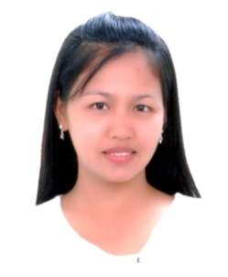
DALIA

DALIA.359958@2freemail.com

Career Objectives
- To obtain a successful career in a good company that will help to attain my goals.
- To deliver an outstanding performance and perform duties to the best of my ability.
- To build good working relationship with colleagues and clients.
Professional Attributes
- Able to handle challenges in multicultural environment.
- A fast learner, hardworking and willing to be trained.
Working Experience

Company :Paniz Mall China Shopping Center
Iran,Kish Island
Designation :Sales Representative
Inclusive date of service :December 20015 up to January 2017

- To give excellent costumer service.
- To give quality sales.
- To promote the products and the company.
- Maintain the area clean and presentable.

Company :Emirates Flight Catering
Dubai, UAE
Designation :Flight Preparation-Holloware and Equipment Section
Inclusive date of service :December 2014 up to October 2015

- Prepares equipment of all emirates flight to be used for catering.
- Check configuration and encode codes of all flights.
- Prepared all types of glasses.
- Updates flights of on-board.
- Preparing the last minute increase of flights coming from the supervisor.

Company :Deluxe Hotel and Restaurant
Cabanatuan City
Designation :Cashier/Receptionist
Inclusive date of service :July 2008 up to 2012

- Taking customers order and entering payment in POS.
- Update work related issues with the manager.
- In-charge for stocks delivery and day end inventory.
- Conduct daily cash inventory and bank remittance.

Trainings
- HABC Level 2 award in food safety in catering (QCF)
Academic Background

College :Two Years Computer Programming
:College for Research and Technology
(S.Y. 2001-2003)
High School :Bongabon National High School
(S.Y. 1996-2000)
Elementary :Macabaclay Elementary School
(S.Y.1991-1996)

Personal Profile

Civil Status :Single
Birthdate :April 08,1984
Age :32yrs.old
Nationality :Filipino
Languages spoken :English ,Tagalog , Arabic
Height :5’1
Religion :Catholic
Reference:

Will submitted upon request.

I hereby declare that the details given above are true and correct to the best of my knowledge.

