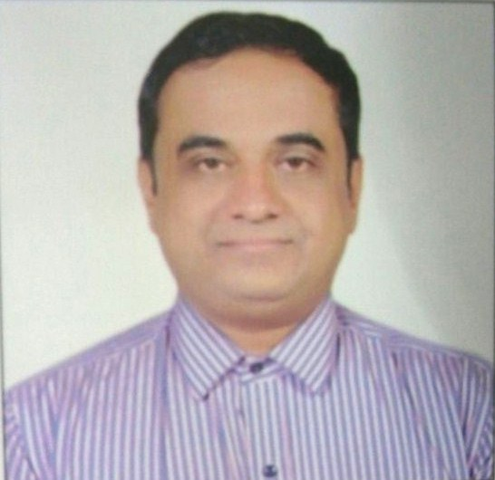
Amol

Amol.359983@2freemail.com

___________________________________________________________________________________

Objective
A young, dynamic and energetic Supply Chain Professional with 15+ years of rich experience in Warehousing, Logistics & Operationsmostly in FMCG Companies looking for a better position in FMCG company to use my professional experience for achieving company targets as well as my personal growth.

Organizational Experience:-
Presently working from March 2015 to till date with Jay Hanuman Milk and Milk Products,Sangamner (Dist – Nashik) as a Sr. Executive– Operations. Jay Hanuman is the manufacturer of Milk &Total Bi-products range with the brand name of “RANJAN”. We are distributing our products locally in the India market.

- Job Responsibilities:-
- Support to Sales Team to develop new distributors.
- Taking orders from the Customers/ Distributors for Milk, Bi Products and ICE Cream.
- Institutional sales planning.
- Punching of orders in the system to process the invoice.
- To search and appoint new distributors/ Customers.
- Directing the functions of Receipt/issue, Inspection, Bill processing &relatedDocumentation.
- Supervising the preparation of other correspondences to provide feedback to top management.
- Taking care for Logistics operation.
- Insure Timely delivery with Quality product.
- Co-ordination with Warehouse,Quality, Production, Account.
- Daily sales & distribution planning.
- Co-Ordination with Warehouse to Ensure Product availability, date of Production n Temperature of the product.
- Daily follow up with Distributors to ensure Full order, timely delivery with quality product.
- Attending the customer issues concerning to Loading, Temperature& transportation related activity & interact with them to resolve it.
- Root Mapping of Containers. /Vehicle.
- Handling customer Complaints.
- Maintaining the records.
- Ensuring customer Satisfaction.

Past Organizational Experience:-
Worked with ‘Foods (I) Ltd. (Pune)’– as an Asst. Manager – Commercialfrom Aug., 2011 to Feb. 2015.

- Job Responsibilities:-
- Responsible for the Branch and Local purchase.
- Working on dot net software.
- Negotiating with vendors.
- New vendor development.
- Coordinating with Production,Quality Control, Accounts, Costing & Customer Service Departments.
- Following up with vendors for continuous supply.
- Ensuring on time delivery of the goods against the order with good service and quality.
- Maintaining the inventory of stock.
- Maintaining of Cycle inventory.
- Follow up with accounts/ Bank for Vendors Payment.
- Dispatch Planning of Local & interstate stocks transfer.
- Disposal the scrap material as per the company norms.
- Material Planning & Inventory Control:
- Managed Day today’s manpower activity.
- Follow up for the slow moving, non-moving and dump stock for smooth functioning.
- Up-keeping the Inward and dispatch records.

ITC Foods Ltd. (Ranjangaon - PUNE) – Worked as WSP Asst.Managerin Chamadia group
(Logistics and Supply Chain)From Nov. 2010 to July, 2011.

- Job Responsibilities:-
- Managed the Finished Goods Stores.
- Managed day today manpower activity.
- Improved Operational efficiencies.
- Ensured on - time delivery of the goods against the order.
- Ensured maximum Optimization of Truck load ability to minimizing the Freight cost
Per kg product.
- Worked on SAP system in SD module.
- Dispatch-planning of local & intra state stocks transfer.
- Maintaining Cycle inventory.
- Maintaining all records as per IMS (Integrated Management System).
- Ensuring Environmental health & Safety at work place.
- Managed more than 100 MT stock. Kept the store ready as per the process
Industry requirement.
- Effective material handling through proper stacking & adopting FIFO/Safety measures
At storage locations to enable smooth and timely movement of stocks.
- Follow up for continuous movement of stock from factory to Hub.
- Follow up for the slow moving, non-moving and dump stock for smooth functioning.
- Up-keeping the Inward and dispatch records.

Mother’s Dairy Fruit & Vegetable Pvt.Ltd. (Pune) - Worked as Sr. Executive (Logistics) - From Feb., 2009 to July, 2010
  - Job Responsibilities:-
  - Follow up with distributors for daily milk orders.
  - Daily sales n distributionplanning.
  - Responsibility of finished goods & total supply of products within desired area.(Milk Section)
  - Management of Primary as well as secondary supply of product.
  - Continuous analysis of Supply chain activity.
  - Negotiating with transporters, shippers/consignees etc. to ensure seamless, cost effective movement of consignment and timely delivery of orders.
  - Directing the functions of Receipts, Inspection, storage, Issues, Bill processing & related Documentation.
  - Overseeing the dispatch of finished products to client locations, adherence to documentation and Internal norms.
  - Controlling effective material handling through proper stacking & adopting FIFO/Safety measures at storage locations to enable smooth and timely movement of stocks.
  - Supervising the preparation of other correspondences to provide feedback to top management.
  - Supervising the fleet of vehicles for ensuring on time delivery & monitoring transit norms.
  - Working in supply Chain Dept. Managing the Finished Goods Stores
  - To maintain the minimum &maximum inventory level.
  - Co-ordination with Production,QC, Account, Costing Departments.
  - Co – ordination with Sales Team for Transactional queries and achievement of monthly business.
  - Disposal/ Scrap the rejected material as per the company/customer policy.
  - Ensuring customer Satisfaction.
  - Improving Operating efficiencies.
  - Ensuring Environment, health & Safety at work place.
  - Punching the orders in the system to process the invoice.
  - Worked on SAP system.

Schreiber Dynamix Dairies Industries Limited, Baramati, PUNE - Worked as an Asst. Manager (Stores) - From Jan., 2001 to Feb., 2009
- Job Responsibilities:-
- Managing finished goods stores. The product ranging from storage temperatures
Of 4 °C to – 22 °C.
Handled UHT Milk finished goods stores.
Maintaining the Juices Finished goods activity.
- To maintain the minimum-maximum inventory level.
- Co-ordination with Production,QC, Purchase, Account, Costing Dept.& Customer.
- Follow-up for the decision of slow moving items, Questionable & obsolete inventory for regular interval with Internal Business Team & customer.
- Co-ordination with all third party viz. Nestle, BNZF, Mother Dairy, Novel Agro, Pantaloons etc. for Finished goods related issues
- Managing of day today’s manpower activity.
- Improving Operating efficiencies toensure customer satisfaction.
- Continuous analysis of Stores activity.
- Up keeping of ISO related records.
- Managing, preserving, identifying, appropriately storing and dispatching the entire range of finished products as per the requirements of ISO 22k, EMS 14001 & OHSAS 18001.
- Negotiation of final rates and issuing of work orders against the quotation & tenders.
- Monthly audit of other section as per ISO,food safety & Human Safety standards.
- Ensuring Environment, health & Safety at work place.
- Member of the different teams formed for modification, optimization, up-gradation, food and human safety, and infrastructure related to activities of stores.
- Developing the logistics network for ensuring seamless, cost effective movement of consignment and timely delivery of orders through MRP.
- Forecasting for finished goods on long Term & short Term basis.

Academic Details:-
D. I. E. - Diploma in Industrial Electronics, 1996 -Board of Technical Education, Mumbai.
D.C.S - Diploma in Computer Software, 1996 - Aptech Computer, Baramati
B.A. - Bachelor of Arts, 2003 - Pune University
MS-CIT, 2006 - MKCL Pune.
SAP SD Module, 2010-Techsteer Institute, Pune
In Computers:-
- Microsoft Word, Excel, PowerPoint etc.
- Knowledge of using FoxPro based inventory control system
- Acquaintance with SAP System and Dot Net Software.
Trainings:-
- Training on Industrial Safety.
- Training on GMP.
- Leadership & Managerial Skill, Interpersonal Relationship.
- Process Excellence.
- Six Sigma.
- 5S quality norms.
- Internal Auditor / Auditee for ISO 22K.
- Internal Auditor/Auditee for EMS14001 & OHSAS18001

I hereby declare that the information given above is true to the best of my knowledge and belief.

