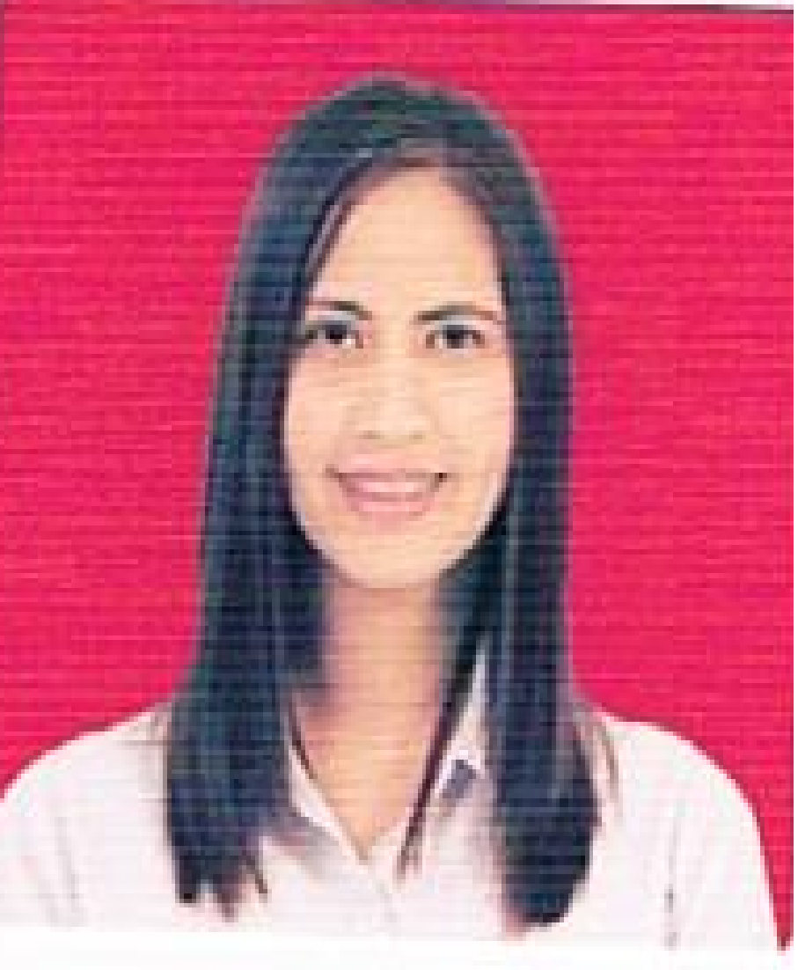
ANN
ANN.360019@2freemail.com
Abu Dhabi, UAE

OBJECTIVE:
I am a highly qualified and motivated trained employee looking for employment that will give me a suitable position that will meet my qualifications.

EMPLOYMENT HISTORY:
DATE COMPANY AND ADDRESS JOB TITLE

JULY 21, 2005 – March 30, 2017 M.Lhuillier Financial Services Inc Branch Manager / Vault Custodian/ Teller
Financial Services / Pawnshop Frontliner Assistant/ Appraiser
- Manages the branch operations andensures that operations are customer
friendly, cost-efficient, and profitable.

- Check the cash receipts and disbursements.

- Record Book and ensures that the actual cash count balances with the record at closing hour.

- Perform the tellering functions of the branch operation in accordance to the routinary duties and responsibilities as teller.

- Giving customer the best service and satisfying their requirements.

- Carefully appraises item being pawnedand subjects them to appraising procedures using the proper testing instruments

TRAINING AND CREDENTIAL:

WESTERN UNION OPERATOR'S TRAINING
November 2006
Makati City

JEWELRY APPRAISAL SEMINAR
December 2006
Makati City

WESTERN UNION SEND OUT TRAINING
February 2007
Makati City

KWARTA PADALA OPERATIONAL TRAINING
May 2007
Makati City

First Line Ambassador's Training and Incentive Program
November 2007
Makati City
KNOW YOUR MONEY AND COUNTERFEIT DETECTION SEMINAR
June 2009
SACOP, City of San Fernando, Pampanga

ORIENTATION ON ANTI – MONEY LAUNDERING ACT
February 2010
Makati City

INTEGRATED SEMINAR-WORKSHOP ON NURTURING WORK ETHICS
THAT COMPANIES VALUE MOST AND EXECELLENT CUSTOMER SERVICE
December 2011
SACOP, City of San Fernando, Pampanga
SKILLS:
• Computer literate
• With good communication skills
• With pleasing personality
• Can work under pressure
• Determined and enthusiastic, strive to get the job done
• Meets quota on time for submission of report

PERSONAL DATA:

Date of Birth : May 30, 1982
Age : 34 years old
Civil Status : Married

EDUCATIONAL BACKGROUND:

DATE SCHOOL / ADDRESS

1999 – 2003 Angeles University Foundation BS in Computer Science
Angeles City

I, hereby ascertain that all facts pertained to in this document are true and credible.

