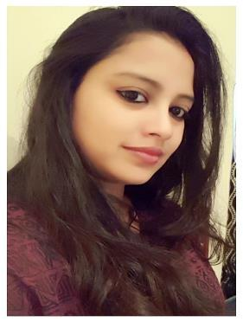
PAMMI
PAMMI.360078@2freemail.com

About Me

-An energetic, unique thinker and eager to learn new technology student of B.F.Tech (Apparel production).-Proficient in technology which is collaborated with fashion technology and design.
-Can adopt new technology easily.
-Can handle various jobs in the same time

STRENGTH

-Adaptability-versatility -Positive attitude

-Dedication towards work -Honesty and sincerity

-Punctuality, hardworking and disciplined

KEY SKILL

-MS-Office
- Visual basic
–SQL

-HTML -ERP

-E-Commerce -Visual StudioBasic

-CAPP (Computer aided production & planning)

-CAD

OBJECTIVE

To Seek an excellent and multi-sided retailing and merchandising career at a reputed and well-liked fashion apparel organization which provides me avenues for professional learning and makes good use of my technical skills and encourage individual growth.

CAREER CREDENTIALS

-Higher secondary school (10th), from A.N.D. Public School Biha,2005,Percentile-65%

-Senior secondary school (12th), from A.S.R.L.SCollege,Bihar, 2009-2010,percentile-71%

-Graduation in department of fashion technology, from National Institute Of FashionTechnology, 2012-2016, Chennai with CGPA- 5.6

WORK EXPERIENCE/PROJECT

- Graduation Project- 2016

14 Weeks graduation project in Landmark Group of fashion, Max (U.A.E)

-Apparel Internship-2015

14 weeks apparel internship in Nahar Spinning Mills Ltd,Ludhiana Punjab

-Textile InternshSip-2014

Two weeks textile internship in Arvind Mills Ltd , Denim Division,Naroda, Ahmedabad. -Summer Project 2013 on Green Fashion

INDUTRIAL EXPOSURES:

- Worked for Indian Terrain, Road show 2015 .

- Imperial Readymade garments factory India pvt ltd.

-Ordnance Clothing Factory, Avadi, Chennai .

-Intimate Fashion, Chennai

-Evolov Clothing, Chennai

-Celebrity, Chennai -Ramji

-Leather, Chennai

CO CURRICULAR ACTIVITIES

-Won 1st prize in football match organized by National Institute Of Fashion Technology, Kannur(Kerala)

-Won 2nd prize in creative writing skills organized by National Institute Of Fashion Technology, Kannur(Kerala).

-Won many other prizes in singing competition.

DECLARATION

I hereby declare that the above mentioned information given is true to the best of my knowledge and belief.

Date-

