CURRICULUM VITAE  Muhammed  Muhammed.360096@2freemail.com | 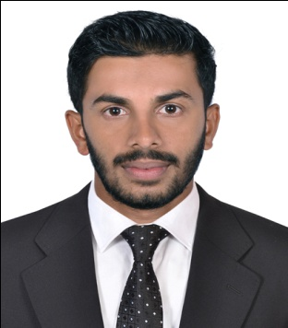

Objective

To secure a challenging job in a reputed organization where capabilities, skills and experience can be fully employed in a productive way, thereby enabling the success of the organization and up gradation of self potential
Personal Profile
- Dealing effectively with multicultural environment
- Excellent team player, dedicated and hardworking person
- Outstanding communication, presentation, negotiation, planning and analytical skills
- Strong work ethics with positive and confident personality
Work Experience (United Arab Emirates)
2 year working in Cashier, Customer Service, Assistant accountant and Inventory at al Mubarak super market Alain as Accountant. mycom software
(Now 2 year complete)
Educational Qualification
Year | Course | Specification | Percentage | Board
2012 | Diploma | Hardware Networking  Engineering | 70% | Board of Southern Institute of vocational Training
2008 | PLUS TWO | commerce | 57% | Board of Higher Secondary Examination
2006 | S.S.L.C | Basic | 68% | Board of Public Examination Kerala

Computer Qualification
- Computerized Accounting For International Management System.
- Tally Erp.09
- Peachtree

- Knowledge in Hardware& Network .

- DHNE-
- Ms OfficeWord,Excel
Personal Details
Date of Birth : 18/10/1991
Nationality : Indian
Marital Status : Single

Declaration
I hereby declare that all the above information are true and correct to the best of my knowledge and brief further, I would like to reiterate that if an opportunity is given to service in you esteemed organization, I would prove to the best of my abilities and come up to the expectations of my employer.

