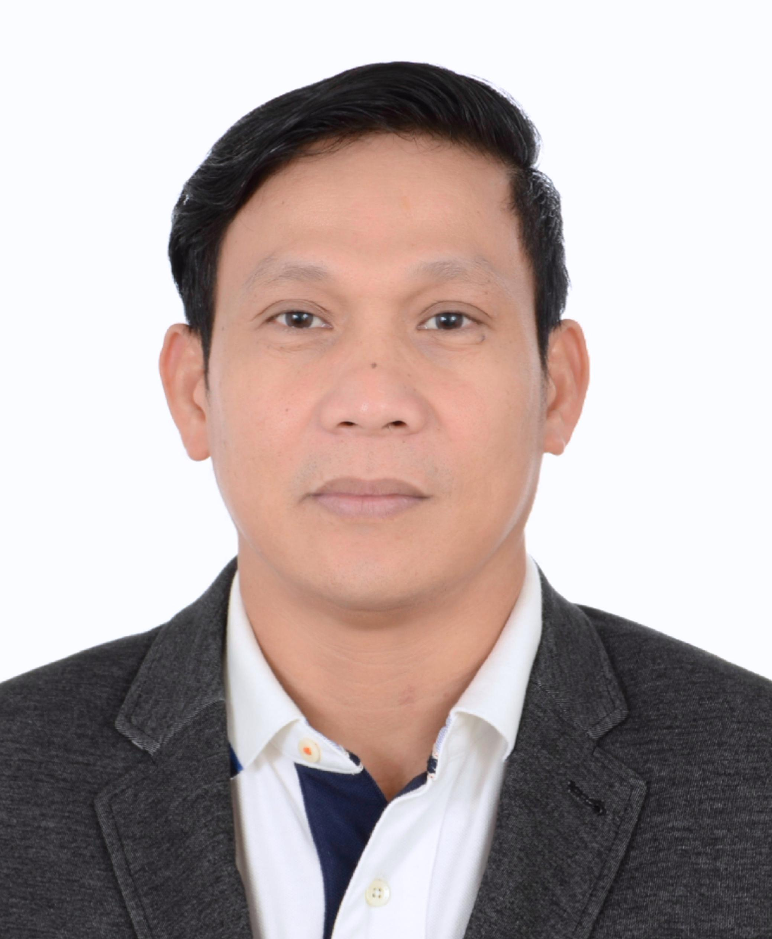
R O D R I G O
RODRIGO.2160672@2freemail.com

EDUCATION

PROFESSIONAL AFFILIATION

Bachelor of Science in Civil Engineering

Technological Institute of the Philippines (TIP), 1990

Philippine Institute of Civil Engineers

Licensed Civil Engineer

Professional Regulation Commission,

EXPERIENCE

Oct 2010 – 30 Mar 2017 Rafael Viñoly Architects Abu Dhabi, UAE

Project Engineer

- Monitoring and supervising structural works including piling works

- Coordinating with Structural Inspector, MEP Inspector, and Contractor regarding changes and discrepancies between site and drawings
- Monitoring all inspection requests and carrying out inspection and snagging of all architectural works together with the Contractor
- Issuance and closing of NCN and site observation report

- In-charge of signing ADM (Abu Dhabi Municipal) forms prior to the inspection of ADM Inspector
- Conducting daily inspection of the workmanship quality of the project

Dec 2008 – Jul 2010 Bando Engineering and Construction Co., Ltd. Dubai, UAE

Senior Site Engineer

- Supervising site and monitoring structural works

- Carrying out inspections together with the Consultant, TECOM, and Dubai Municipality Engineer

- Preparing and submitting daily TECOM inspection requests

Feb 2008 – Nov 2008 Nakheel Dubai, UAE

Construction Executive

- Daily site progress monitoring and documentation

- Coordinating with other projects, EHS, and contractor/sub-contractor all issues regarding safety, access, & technical drawings
- Monitoring and inspection of the workmanship quality of projects

- Preparing monthly progress reports for the Project Director and other parties

May 2006 – Jan 2008 Sumitomo-Mitsui Construction Co., Ltd. Makati City, Philippines

Senior Site Engineer

Joint Venture with Obayashi Corporation (Dubai, UAE)

- Supervising bored piling works, drilling, lowering of casing/rebar cage, and concreting works (in-cluding rebar cage fabrication & installation, rebar & formwork installation, and pier concreting)

- Monitoring sheet piling, excavation, and waterproofing of every pier

- Checking shop drawings and coordinating with the consultant in case of discrepancies

- Preparing construction schedule and attending weekly meetings with other contractors to discuss weekly schedule, deliveries, access, and safety issues

- Reviewing pre-qualification documents, requesting & evaluating quotations, and assessing competency of suppliers and subcontractors

Apr 1996 – Apr 2006

Sumitomo-Mitsui Construction Co., Ltd.

Site Manager

Makati City, Philippines

- Managing technical & supervisory staff and overseeing & scheduling allocation of manpower, equipment, & materials

- Comparing design drawings with shop drawings and coordinating with client and consultant for implementation, as well as corresponding directly with client/representative and consultant regarding all technical and contractual matters

- Evaluating all claims for subcontractors’ payments and checking drawings and bill of quantities for possible variation claim, then preparing variation order if necessary

- Preparing and submitting reports on milestones, monthly schedule, and monthly progress

May 1992 – Mar 1996 | InPhase Construction Company, Inc. | Marikina City, Philippines
 | Project Engineer / Quantity Surveyor
Dec 1991 – May 1992 | Manser Leak & Seep Specialist | Quezon City, Philippines
 | Project Engineer
Aug 1991 – Nov 1991 | Technotest, Inc. | Quezon City, Philippines
 | Survey Assistant
Feb 1991 – May 1991 | John Michaels Engineering & Construction | Quezon City, Philippines
 | Cadet Engineer

PROJECT EXPERIENCE

MIXED USE | New York University Abu Dhabi | Saadiyat Island, Abu Dhabi
 | Campus and educational facilities comprising 18 towers (2B+P+14)
 | U-Bora Towers | Business Bay, Dubai, UAE
 | Office Tower (2B+5P+53) and Residential Tower (2B+5P+16)
TRANSPORTATION | Palm Jumeirah Monorail Transit and Stations | Palm Jumeirah, Dubai, UAE
 | 5.2 km monorail with 4 stations
 | The Palm Gateway Towers & Carpark Podium | Palm Jumeirah, Dubai, UAE
 | 14-storey carpark with residences and depot for monorail
HOTEL | Leo Palace Hotel | Guam, USA
 | Reception building with exercise pool
POWER & TELECOM | 230 kVA Power Transmission Line | Cavite to Batangas, Philippines
 | Globe Telecom Phase 10 | North Luzon, Philippines
 | Globe Telecom Eastern BSC Protection | Visayas Area, Philippines
 | Globe Telecom MSC Building | Tarlac, Philippines

PROJECT EXPERIENCE

FACTORIES | Shims Philippines | First Philippine Industrial Park (FPIP), Philippines
 | Komyo Philippines | FPIP, Philippines
 | SB-Flex - Phase 2 Expansion | FPIP, Philippines
 | Isola Philippines Factory - Phase 2 | FPIP, Philippines
 | Photocircuit Philippines | FPIP, Philippines
 | Sumisola Philippines Plant | FPIP, Philippines
 | Miyoshi Philippines - Phase 2 | Batangas, Philippines
 | Shimpo Philippines | Laguna Technopark, Philippines
 | Nidec Philippines | Laguna Technopark, Philippines

TRAINING & SEMINARS ATTENDED

May – Jul 2010 | Primavera (P6)
Apr 2008 | Quality for Project Managers – ESI International
Apr 2008 | Managing Projects – ESI International
1996 | Clean Room and Contamination Control Technology
1993 | Comprehensive Computer-Aided Design & Drafting (CADD)
1992 | Computer-Aided Project Management

REFERENCES Available upon request

